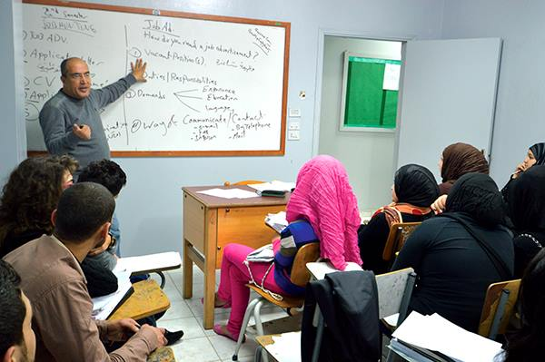ALI SHEHAB MUSTAFA KASSEM SABBAH

Lebanese

# Beirut 1973

Married

E-mail: [sabbahali@hotmail.com](mailto:sabbahali@hotmail.com)

Mobile: 0096176983069

*Objectives:*

*Encourage active learning and group participation in the classroom, thereby helping students to become productive and successful society members.*

*To obtain a position that will enable me to use my strong classroom skills, educational background and ability to work well with others.*

*Experienced special education counselor with skills to overcome challenges and help students and peers achieve goals.*

*Education:*

* Beirut Arab University  *B.A in English Language and Literature 1995*
* LCCI : Business English Level II/Business Administration Level II

*Training and Workshop*

* Teacher’s Training Certificate from National Center for Educational Research and Development (Lebanon).
* Teacher’s Training Certificate from British Council (Beirut).
* Teacher’s Training Certificate from I.C International College (Beirut) in the following courses:
  1. English Language Games and Activities.
  2. Implementing Values in the Curriculum.
  3. A Story speaks a 1000 Language.
  4. Interactive Learning.
  5. Organizers and Learning
* Certificate in "Active Methods in Teaching" from Almabarrat Association/Beirut
* Certificate in " Training Methods for Trainees" from the Lebanese Management Association (LMA) Beirut.

*Experience:*

* 2018-2019 Teaching English Language for grades 5&6 ( Syrians)@ Haarat Naame Public School/ Official Curriculum
* 2012- 2019 Teaching Business English and English Correspondence for Advanced Level @ Youth for Development Vocational Training Center
* 2004- 2012 Teaching Business English and English Correspondence for Advanced Level @ Norwegian People's Aid Vocational Training Center
* 2003-2005 teaching English Language and English Correspondence@ IZET Technical Institute:
* 2002-2003Teacher of English Language Technical Baccalaureate: Mechanics – Computer Science Informatics – Air Conditioning – Electronics – Electricity@ Ali Al-Akbar Technical Institute.
* 2001-2002 Teacher of English Language (Pre-School Education) Technical

Baccalaureate@ Ali Al-Akbar Technical Institute

* 1999-2001 Teacher of English Language *( Grades 5,8,9+10 IGCSE) &* Teacher

of Social Studies *(Grade 3 to Grade 8 @* Lebanese International Private School

( Abu Dhabi).

* 1996-1999 Teacher of English Language *– Elementary, Intermediate, and Secondary Classes* @ Lebanese Typical School ( Beirut ).
* 1995- 1996Teacher of English Language – Intermediate Classes@ Al Anwar School (Beirut).

*Skills:*

* Typing: English 60 wpm – Arabic 40 wpm
* ICDL: International Computer Driving License

*References:*

* Adnan Nofel, School Director, 009613506170
* Amal Shazli, Moussawat NGO project officer, 009613963636