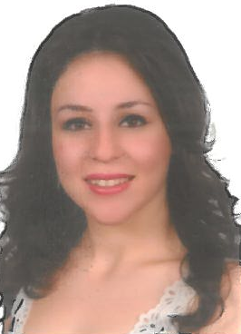 phone : 01-332649

Mob. : 70-620258

e-mail : carinenohra@yahoo.com

## 

## Carine AL Laham

### Personal Information

Marital Status : Married

Children : 3

Nationality : Lebanese

Gendre : Female

Age : 27

Home Address: Dekwaneh- Al Midan Street –Saba Bldg-3rd Floor

#### Education

2015-2016; LT Management and organisation **IPNET DEKWANEH**

2013-2015 ; TS degree Management and organisation **Institut tourisme**

**DEKWANEH**

2007-2010 ; BT degree Accounting passed successfully with a certificate from the British Council in communication and organization skills.

**Bourj Hamoud Official School**

Grages 8 and 9

**LCMS _Lebanese Canadian Modern School – Rachaya**

Grades 6 and 7

**Collège des soeurs du rosaire- Bourj Hamoud**

Primary Cycle

**Experience**

Since January 2018 , working at Catland Contarctors –Mansoureih as an accountant , assistant office manager, preparing the agenda , the documents and taking notes during meetings, managing telephone calls, filing and documentation, prepare reports as requested, performother duties that serve the purpose of achieving the cpmany goals as assigned,bank recociliation , salaries,check and generate invoices, check and control petty cash, perform tasks related to data entry, advanced excel skills,………

April 2015 till End August 2016 , working at Publiscreen Online SARL as an accountant ( salaries,NSSF, Vat registration, payments, invoicing, indemnity end of service, petty cash, transfers, reconcilation, outlook…)

From December 2014 till End March 2015, started working at Fanous Clearing Forwarding –Aramex in the accounting department (payments,petty cash,invoices,…)

From March 2013 till November 2013 I have been working in the accounting departement at Hopital Hotel Dieu De France ( MedGulf Invoices , Hospital and Doctors Invoices , Insurances , etc….)

During my studies with the British Council I made a training sessions with different kind of companies ( HSBC, INDEVCO, Hypermarket Bou Khlail, Audi Bank….)

From October 2010 TILL November 2011; Auditing for VAT Invoices and sales at LAHAM Jewellery –Sid EL Bouchreih –Souk EL Sagha.

**Language Skills**

##### Write Understand Speak

Arabic Good Good Good

English Good Good Good

French Good Fair Fair

### IT

## Windows, Word, Excel, Access.

### Interests

Internet.

Making evaluations and statistics of economic prices over several years .

**Further information available upon request**