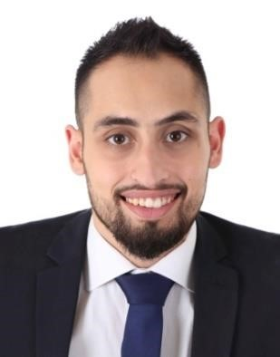
Bassel Souki
Phone : +961 71 885 973  D.O.B: September 21, 1993 | e-mail: bassel.souki@hotmail.com  Address: Shweifat
Objective | Seeking a successful career in my domain, and having the opportunity to be a team member among your organizational staff.
Experience | Jul 2017- Jan 2019 (La Siesta Beach Resort Hotel-Khaldeh)  Financial Accountant  Income Auditor, preparing daily revenue reports, and cash audit.
Responsible of the cashiers (Training on software for F&B department entrance and receptionist, spot checks, schedule…)
Audit and control all accounting transaction related to bank accounts, deposits, transfers, withdrawals, supplier’s checks, owner’s company, management’s accounts and bank reconciliations.

Close accounts, control expenses, provisions, cost income, and inventory.
Prepare monthly payroll, NSSF schedule..
File the income tax on salaries and wages and the VAT (value added tax).

Accounts receivables; meeting with clients to agree on the method of payments, and follow up to collect the money.

[ Jan 2016- Oct 2016] Ready Mix Concrete Of Lebanon (RMCL )
- Administrative responsibilities - charge on employees some tasks
-Cardiff Metropolitan University in Britain – certificate in Management

[Jan 2013] Aromate- Manufacturing. Food & grocery. Food & Beverage service & distribution ( ISO FOOD)
- Administrative responsibilities - charge on employees some tasks
Education | [ 2013- 2016 ] Modern university for business and science- Faculty of business. - British academy in Lebanon Cardiff university  Bachelor degree in Business using BAL system  [2012] Chouiefat Official Secondary School Chouiefat, Lebanon; Baccalaureate Degree –SE.
Languages  Computer Skills | Arabic (Mother Language): Read, Spoken, Written.  English (Fluent): Read, Spoken, Written.  Word, Excel, Wizard, Omega.

