**CV** References Available Upon Request

**Sarwat Hilal Hajj Chéhadé**

*CHEHIM, LEBANON*

*Nationality: Lebanese*

*Date of birth: September 10th, 1996*

*Email:* [*sarwat-hc@hotmail.com*](mailto:sarwat-hc@hotmail.com)

*Phone: 71161067*

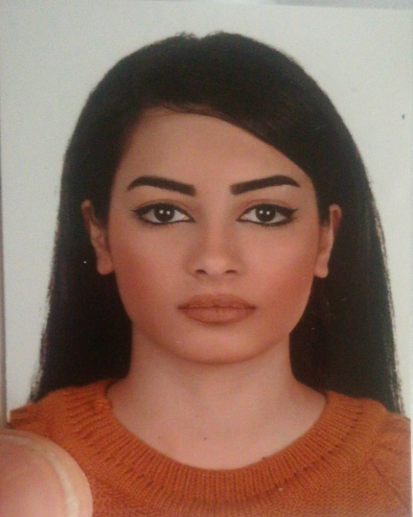

**Education:**

- Collège Universelle, Chehim :

Baccalaureate in Life Sciences

- Lebanese University (2 years):

Travel and Tourism

**Languages:**

Arabic Mother language, Excellent

French Second language, Fluent

English Third language, Fluent

Spanish Forth language

**Interests:**

Biking

Swimming

Reading

**Skills:**

Good team management skills built through various team projects during my school years as well as in LU and Beyond Learning. Fast learner, adapts easily to new situations. Responsible, organized.

**Computer skills :**

* Microsoft Office Word
* Microsoft Office Excel
* Microsoft Office Power Point
* Computer and Internet skills

**Also:**

* IATA advanced courses

**Training:**

* Two months at MIDDLE EAST AIRLINES (Rotation in the airport, and in Cedar Miles Department).
* One month in NEW LINE TRAVEL AGENCY

