 | Cynthia Nasr  Lebanon, Tripoli  Phone: +96171318836  E-mail: cynthia_nasr@hotmail.com  Marital Status: Married  Nationality: Lebanese  Date Of Birth: 19/08/1989 | 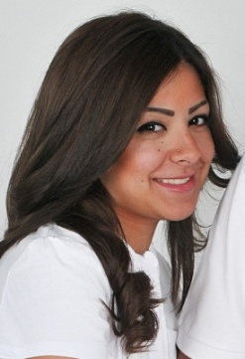

Objectives
To make lifetime contribution, by virtue of my skills and education within an organization of high repute with a view to attain long-term career.

Education
University Of Balamand, Lebanon

- MA Degree in Mass Communication/ Adv, PR and Marketing (Spring 2013)
- BA Degree in Mass Communication(2010-2011)
Minor In Drama Theater

Thamer International School of Jeddah, Saudi Arabia

High School (Class of 2007)

Experience

- Manna Beauty Center (Jeddah, Saudi Arabia)
(November 2013- July 2017)
- Marketing Manager
  - Volunteer with Zahra Organization to help raise awareness on cancer
  - Volunteer with SAGA Organisation; Member of “Make the CUT’ to help create wigs for cancer patients
  - Event Planner for private birthdays for kids
  - Social media Specialist for MANNACENTER and JEANLOUISDAVIDSA instagram accounts.

- Abdul Rahman Hallab & Sons ( Tripoli, Lebanon)
(March 2013 – July 2013)
- Social Media Intern

- TM Magazine (Achrafieh, Lebanon)
(June 2011- September 2011)
- Copywriter intern

- Interned with Zeina Daccache inside the lebanese prison of Roumieh for Dramatherapy on prisoners documentary
Roumieh Prison ( 2011)

- Sawt El Shaeb Radio (Tripoli, Lebanon)
(June 2010-September 2010)
- Broadcaster internship

- Ipsos Stat (Jeddah, Saudi Arabia)
(May 2007- August 2007)
- Call Center

Computer Skills
- PhotoShop (Intermediate)
- Microsoft Office ( Word, Excel, PowerPoint)
- Shortcut Software

Languages
- Speaking, reading and writing Arabic, French and English languages fluently

References

Available Upon Request

