**Andrew Gamal Roudelf**

**Cellular phone: (01226003836)**

**E-Mail: Andrew_roudelf@hotmail.com**

**Adress:Giza **

**SEEKING FOR A JOB OPPORTUNITY.**

**PERSONAL DATA:**

* Nationality: Egyptian.
* Matrial status: Single.
* Military status: Performed.

**EDUCATION:**

* Faculty: graduate of Law.
* Graduation year :2012
* Section: English.
* University: Ain shams
* Major: Sales
* Grade: Good.
* Age:26
* **CAREER OBJECTIVE**::

Seeking a good career in a reputable corporation in the fields of:

Working in shops as a sales person for markets and cafe

**CONTINUING working**

Accept to work abroad

**LANGUAGE**:

* Arabic: Native.
* English: Very good speaking and writing.

**COMPUTER SKILLS**:

* Office 2007 and good user of the internet windows 7, exel ,word power point , access

.

**OTHER COURSES:**

* ICDL Computer Driving License) Certificate.
* English course.

**OTHER SKILLS**:

"Strong communication, organization skills, and customer follow up"

"Ability to conduct physical work, frequently lift 15 lbs and occasionally up to 50 lbs"

"Outstanding telephone and customer service etiquette skills"

"Naturally persuasive with some leadership potential mixed in"

"Ability to travel"

Is This Occupatio

* Ability to work under pressure.
* Ability to learn fast and acceptance of knowledge and experience.
* Ability to work in a team. Duties include (please see full spec):
* • Deliver the professional greeting of clients and visitors to the highest standard
* • Maintaining a welcoming and friendly atmosphere in the office
* • Managing incoming enquiries (in person, email and on telephone)
* • Keeping the website up to date
* • Support for all teams within the Events Dept (Social Media, Operations, Sales, Markets etc) and wider business
* • Liaising with Event Clients, Estate Tenants and Market Traders
* Skills & Characteristics:
* • Presentable, friendly and outgoing character
* • Excellent interpersonal and communication skills
* • Excellent telephone manner
* • Efficient organisational skills with good time management
* • Ability to prioritise workload and meet tight deadlines
* • Proficient computer skills including knowledge of Excel, Power Point and Word
* • Ability to demonstrate personal drive and commitment to work
* • Knowledge of East London

Monitors competition by gathering current marketplace information on pricing, products, new products, delivery schedules , merchandising techniques, etc.

Recommends changes in products, service, and policy by evaluating results and competitive developments.

Resolves customer complaints by investigating problems; developing solutions; preparing reports; making recommendations to management.

Maintains professional and technical knowledge by attending educational workshops; reviewing professional publications; establishing personal networks; participating in professional societies.

Provides historical records by maintaining records on area and customer sales.

Contributes to team effort by accomplishing related results as needed.

Sales Representative Skills and Qualifications:

Customer Service, Meeting Sales Goals, Closing Skills, Territory Management, Prospecting Skills, Negotiation, Self-Confidence, Product Knowledge, Presentation Skills, Client Relationships, Motivation for

**WORK EXPERIENCE**

Direct sales in spinney's hyper markets

* Contract period 1 year
* Location: Haram street
* The describtion of the job
* Section of FMCG -(Rize-milk-coffee-choclate-tea-)

Sales for the wear of the women and men

* 1- to deal with customers for buying the goods such electronic instruments(soul tanks. Air compressor ,torch ,trays,dishes for food,garmets ceramic the type is novale stalless steel, store for keeping the foods cold and hot curthain bath, kitchen machines.

The staff of clothes: Sales for the wear of the women and men

Home appliances department

(sweet shirts trousers jeans under wear clothes for childrens with different colors not only for men but olso for womens.screw diver property, car pedales)

Staff of drinking: henkine and cold big cola Jeans filling t-shirts new fashions

Bakery staff :

making cakes chocolates

staff of fruits &vegetables :

staff of food :selling meat . chikhen , fish

2-Service the client about the goods&promotions with a negotiable price.

3-help the customer to find the best goods that he want.

4-the character to deliver it by phone.

5-electric instruments katels- refregeratores -tlevision plasma- Toshiba-elaraby

Camera filters



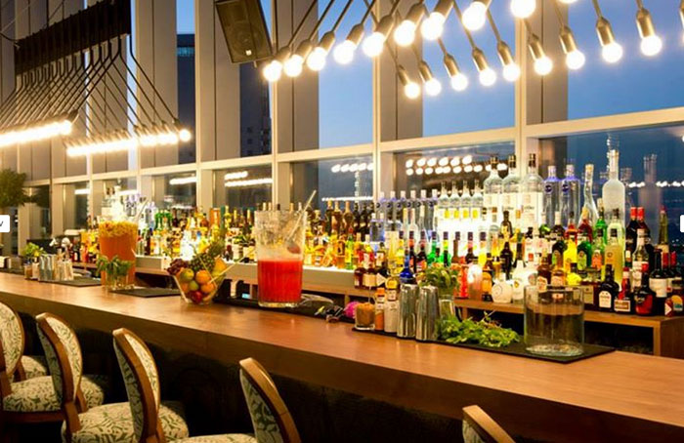

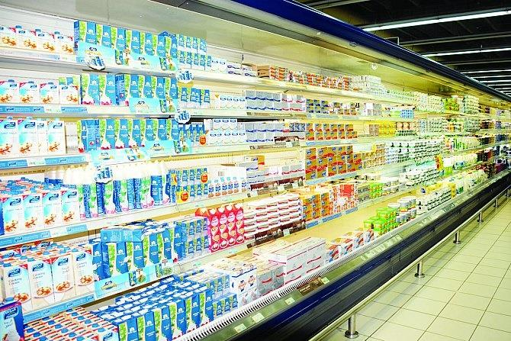

.

REFERENCES FURNISHED UPON RESPON