**Mohamed Abd El-Rahim Mohamed**

# 52 Mohamed Ramzy St. Heliopolis – Cairo-Egypt

**Cell :** **+201003540604 / +201001413198**

**Home : +20226211962**

**E-Mail :** [**hminem@hotmail.com**](mailto:hminem@hotmail.com)

**Biographical Information :**

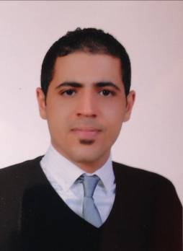

* **Date of Birth :** Feb 22, 1986.
* **Nationality :** Egyptian.
* **Marital Status :** Single.
* **Military Status :**  Exempted.

**Academic Information:**

* **University** **:** New Cairo Academy ( Information System)
* **Degree** **:** Bachelor of Information Systems.
* **Grade** **:** May – 2008.

**Work Experience:**

* **Engineering Consultants Group – ECG** , from July 2014 tillPresent. ( Site Document Controller )
* **Hiea Association Under Egyptair Cargo management** , **From:** March2014 ,**To** June2014. ( Cargo Officer In Cairo Airport )
* **Altayyar Travel Group - Saudi Arabia** , **From:** December2010,**To** july 2012. ( Ticketing & Reservation )
* **Royal Jordanian Airlines** , **From:** June 2009, **To** November 2010. ( Traffic Officer In Cairo Airport )
* **Ancient Royal Tours** , **From:** December 2007, **To** May 2009. ( Customer Service )

**Certificates:**

* Amadeus selling platform .(Grad (A)

**Languages Skills:**

* Arabic : Mother Tongue.
* English : Excellent to communicate in a business environment.

## Computer Skills:

* Email, Social Media, and Blogging
* MS Word, Excel, and PowerPoint
* Professional typing rate of 70 wpm
* Software / Applications
* Operating Systems
* IT Troubleshooting
* Spreadsheets and Databases

**Personal Skills:**

* A flexible work schedule and I’m available most any time.
* The ability to follow directions with accuracy and act as representative for the firm when the need arises.
* Knowledge of how to perform general office duties.
* In my previous job I gained a lot of experience and managerial skills from the training that I got in the company. I got used to working under pressure and found it easier to communicate with different nationalities and ages

*,* *I hope that you'll take my experience and consider me for this position. It’s an excellent opportunity to learn and grow in this field and I’m confident I can be a positive influence and make many contributions to your company.*

***Mohamed Abd El-Rahim***