**CURRICULUM VITAE**

**malek w. el-far**

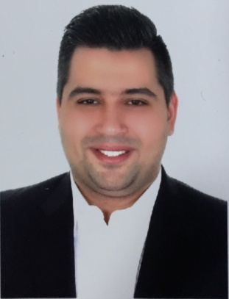

**Nationality:** Lebanese

**Material Status:** Single

**Date of Birth:** 10 February 1984

**Phone**: +961 78917949

**E-mail**: [elfarfreight@outlook.com](mailto:elfarfreight@outlook.com)

**Career Objective**

Being young, dynamic and ambitious, I aim at utilizing my potentials to find a challenging position that meets my competencies, capabilities and education in parallel with Company’s objectives, and to secure a promising position that offers a good growing Future.

**Education & Personal Skills**

* American university of culture and education [AUCE] [Lebanon, Beirut] Management information system (2 year).
* Lycee Minette Moderne [Lebanon, Beirut] Graduate of Socio-Economy 2005.
* Languages: Arabic, English and French (writing and reading fluently).
* Computer literate: Microsoft Office, Adobe, Omega, Cubase, Nuendo.
* Dynamic, achieved oriented and ability to learn.

**Professional Experience**

* **EL-FAR FORWARDING AGENCY**: Sea freight & Air freight Beirut, Lebanon.

From 2006 – Present

* + **Assistant Manager :**
* Receipt documents with clients and shippers.
* Contact Logistic agencies about shipments and know the freight cost and receive the D/O to start document process.
* Feedback clients about all shipments tracking and vessel arrival information.
* Conducting customs transactions and pay their fees in order to complete goods transportation out of sea or air port.
* Confirm on goods transportation from sea or air port, to client warehouse destination and contact with client about the goods receiving.
* **KASKAS LIGHTING:** Beirut, Lebanon. From 2008 – 2011.(Part time)
  + **Sales Representative:**
* Achieved assigned monthly sales target.
* Gain a clear understanding of customers and their requirements.
* Visit customers, maintaining and developing relationships.
* Prospect new customers and developing assigned route.
* Extend solutions to the new and existing accounts to increase value sales.
* Organize, maintain and report an effective administration system that includes customer record cards, journey plan and sales history to meet required monthly targets.
* Follow up on collections for the assigned customers.
* **Saudi Airlines Catering**: Saudi Arabia, Jeddah / Makah Hajj & Umrah Department 2014-2015:
* **Senior Supervisor:**
  + - Provide catering services to businesses (B2B) for Hajj and Umrah pilgrims.
    - Provide safe, quality, on food based on delegation and client needs for consumption by pilgrim

**References -** Ready upon request.