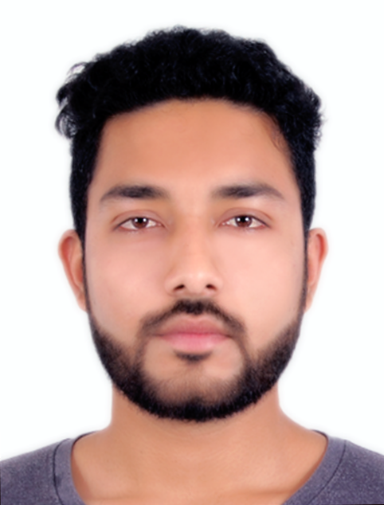 **Moosa Qureshi**

**Mobile: +917509573775, +971582479846**

**Email:** moosaqm@gmail.com

**SUMMARY:**

Energetic Tourism Manager with around 3 years of experience in Tours and Events Planning, Operations & Management. Highly driven & skilled at finding new ways to enhance visitor’s experience.

**Key strengths include:**

**• Tour Management & operation • Event planning, organizing & Managing • Trekking & Tour Leading • Guest Relation**

**• Package sales and customer service • Itinerary and Tour Planning • Keeping track of the tourist and service providers**

**EMPLOYMENT HISTORY:**

**Blush Events Bhopal (India), Events Manager (July 2015-December 2016**)

- Successfully lead, organized and delivered events

* Drove cost effective and on budget purchasing through negotiations with suppliers
* Ensured maximum effect of branding through backdrops,standees & different branding techniques.
* Seamless logistics and travel arrangements for the clients tailored accordingly.
* Kept track of the timely execution of the decisions and action points formulated during the meetings
* Obtained timely approval from the Finance Chair on any not-planned expense
* Foresee space allocation needs for the total Event and propose to the General Chair appropriate plans for meeting these needs
* Always prepared to perform any task found necessary which was not described
* Assist holidaymakers check-in and settle into their accommodation
* Communicated a range of information on itineraries, destinations and culture
* Responded to questions and offering help with any problems that arise, ranging from simple matters, such as directing a member of the group to the nearest chemist, to more serious issues, such as tracing lost baggage
* Making contact in advance with places to stay or visit to check details and arrangements
* liaising with hotels, coach companies, restaurants and other clients
* Organized and attending Events, conferences, workshops, seminars and exhibitions

**Freelance Trekking and Tour Leader worked with Madhya Pradesh Tourism Department**

- Organized Trekking weekend trips to different destinations

- Lead city walks in Delhi & Mp. Told people about the time-line of the Sultanates & Rulers of India

- Basic first aid technique

- Managed large group of people on walk tours & Trekking tours. Made sure to maintain harmony & concord among people

- Researched destination by visiting and making sure that its safe to go.

- Marketing Products and made sure to prepare products according to the current need & competition

- Collected information from the trekkers to contact in case of emergency

- Got proper permits to enter the restricted zones.

- Checked equipment and teaching how to use that in case of emergency

- Setting guidelines and taught people what to carry and what not to

- Setting up camps & safety in case of any emergency

- Made sure not to attract wild animals

- Survival techniques

- Educating tourists about the cross cultural issues of the local people. what to talk & what not to

**Successfully completed 45 days as a Summer Intern with Thomas Cook India Ltd. Mumbai during (May 2014 to June 2014)**

**Air Arise Tours and Travels, Bhopal (India), Tour Operations Executive (January 2012 - March 2013)**

- Be the main contact person between the potential client and the company

- Convert personal travel wishes into tailor-made travel proposals

- Ensured all necessary steps are being taken from the inquiry, booking, execution to evaluation of the tour

- Handle feedback and complaint in a professional manner

- Assist in annual business report writing

- Acted as a liaison between the office and the field staff (drivers, guides and freelancers)

- Supervised the hotel reservations desk

- Worked in complete cooperation with the rest of the office team (reservations, account and manager)

- Be flexible to work outside office hours if necessary

- Optimize tour handling and other administrative procedures

- Assisted in new product development

- Made Itineraries and researched new destinations.

**EDUCATION:**

• Masters in International Tourism Business from Indian Institute of Tourism and Travel Management, Gwalior, India (2013-2015)

• Bachelors in Tourism and Travel Management from Bhopal School of Social Sciences,Bhopal, India, (2010-2013)

• Higher Secondary School Certificate from People’s Public School C.B.S.E Bhopal, India. (2010)

• Secondary School Certificate from, People’s Public School C.B.S.E Bhopal, India.(2008)

• Passed TOEIC Examination in 2016 with 855 Scores

**SYSTEM SKILLS:**

• Microsoft office, Word, Excel

**PERSONAL DETAILS:**

Hobbies : Exploring places, Scuba diving, Fitness, Swimming, Boxing, Interacting with people , Adventure Sports,Travel log, Social Welfare.

Date of Birth : 15-06-1992

Nationality : Indian

Languages : English, Hindi & Urdu.