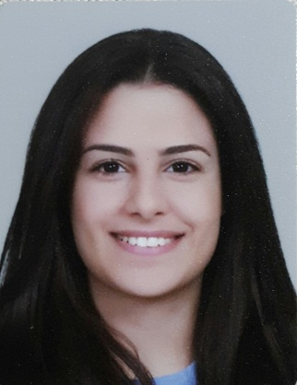 **CURRICULUM VITAE**

Career Objectives

|  |
| --- |
| Seeking a job opportunity that can give me different kind of new audit/accounting experiences and exposure in a nice working environment to develop my experience and my personality skills . |

Personal Details

|  |  |  |
| --- | --- | --- |
| Full Name : | Mariam Ahmad Mouslemani | |
| Gender : | Female | |
| Nationality : | Lebanese | |
| Date Of Birth : | April 2nd , 1995 | |
| Marital Status : | Single | |
| Address : | Beirut , Tariq Aljadida , Salam building- 1st floor | |
| Telephone : | 01319018 | Mobile : 76067211 |
| E-Mail : | Mariam_Mouslemani@outlook.com | |
| Languages known: | First language : English  Second language : French , Arabic | |
| Health : | Very Good | |
| Interests : | Music , Reading , Sports , Travelling | |
| Occupation : | Fresh Graduate , Graduated on June 2017 | |

Educational Background

|  |  |
| --- | --- |
| 2013-Now | Beirut Arab University – Beirut Lebanon  Bachelor of Banking & Finance  Gpa: Expected 2.8 |
| 2011-2013 | Roman Ridge School / Cambridge International Examinations – Accra Ghana  GCE A Levels – General Certificate of Education Advanced Level  Gpa: B |
| 2010-2011 | Roman Ridge School /Cambridge International Examinations – Accra Ghana  IGCSE- International General Certificate of Secondary Education |

Extra Curricular Activities

|  |  |
| --- | --- |
| 01 Aug. – 31 Aug. 2016 | INFOLIO- Auditing – Accounting- Consulting Company  One month training on auditing , accounting , consulting , and on all other operations involved in INFOLIO |
| 01 June – 09 July 2015 | Beirut Arab University - CCPE  ICDL Ver.5.0/ International Computer Driving License  Computer Essentials– Online Essentials – Word – Excel –Power point- Access – IT Security |