Curriculum Vitae

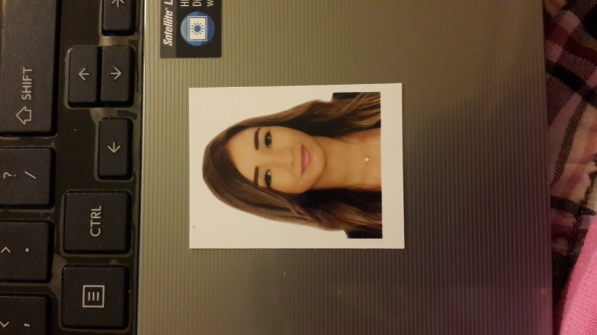

Celine Ourban

Mobile: +96176721224

Email: celine.ourban1@gmail.com

SUMMARY OF QUALIFICATIONS

Sales Associate/ Calzedonia-Le Mall Dbayeh/Azadea

- Greet customers, offer assistance and serve them in order to ensure their needs are answered in a timely manner and in compliance with the customer service standards.
- Arrange and replenish on a continuous basis the shop shelves and ensure that the shop floor and shelves are kept clean at all times.
- Watch for and prevent security risks and thefts and escalate occurring incidents to the hierarchy in a timely manner in order to avert loss.
- Perform physical and electronic inventory of shop products on a regular basis as per company's guidelines in order to ensure accurate stock keeping.
- Specific for Fashion: Take measurements for any needed alteration, assign price according to set pricelist, fill the alteration book, and notify tailor of the amendments

RELEVANT EXPERIENCE

Cashier / Le Charcutier Aoun
2014 – 2015 Lebanon
- In charge for a register during the shift
- Count money at the start and end of each shift
- Ring up the items customers want to buy
- Helps customer through payment options
- Handle exchanges and returns
- Evaluates the condition of the returned merchandise and determine the type of payment use

Sales / Baby & Kid
2013 – 2014 Lebanon

- Sell specific products and services to consumers
- Demonstrate products and show consumers how to maximize their features
- Explain different customizable features
- Discuss warranties and replacement parts
- Process orders in person and over the phone
- check inventory to ensure product is in stock
- Bag and package purchases
- Remove security devices, fold clothes and place neatly in bag
- Collect methods of payment and dispense change.
- Collect and research information needed to identify and resolve problematic situations
- Operate cash registers
- Place clothes on mannequins
- Determine seasonal trends and adjust displays as needed
- Stock shelves

Promoter / JTI Agency
2013 Lebanon

a) Demonstrate and provide information on promoted products/services
b) Create a positive image of the product and lead consumers to use it
c) Distribute product samples, brochures, flyers etc. to source new sales opportunities
d) Identify interest and understand customer needs and requirements
e) Set up booths or promotional stands and stock products
f) Report on demonstration related information (interest level, questions asked, number of samples distributed etc.)

Kids’ Teacher / Garderie Lapinou
2011 – 2012 Lebanon
s
a) Teach Children at the kindergarten level
b) Plan evaluate and assign lessons
c) Use games, music, artwork, films, books and other tools to teach basic skills
d) Use play and hands-on teaching
e) Teach letter recognition, phonics, numbers, etc.
f) Report on demonstration related information (interest level, questions asked, number of samples distributed etc.)

EDUCATION

- 2016: License in Business Marketing & Advertising / AUL Kaslik
- 2012: SE - Sociology & Economics / Lycee Ajaltoun

OTHER SKILLS

- Excellent verbal and written communication skills.
- Languages: Arabic & French (VG), English (G)
- Computer skills: Microsoft office
- Self-motivated with a strong work ethic for professionalism and timeliness.

TRAININGS

- Exceptional Customer Service
- Effective Communication Skills
- Telephone Techniques
- Art of Customer Satisfaction
- Types of Customers and how to deal with each type
- Power of active listening
- Grooming Standards
- Approaching Customers
- Product Knowledge
- Teamwork in action
- Body language insights
- Body shapes

