 | Bilal Mohammad Kobrosly
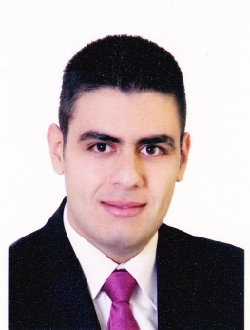 | Beirut-Tarik Al Jadida-Sinjer Building 7th Floor  +961 70 98 10 91  b.kob@hotmail.com  DOB: 07/12/1992  Lebanese

Objective
Seeking a permanent job where I can add value to my academic background, interpersonal skills, and to the further growth of your respectable institution.
Education
Arts, Sciences & Technology University of Lebanon
Business Travel & Tourism will graduate at the end of Spring Semester 2017
Makassid High School
Official BAC II
experience
September 2015 – Till Present |Middle East Airlines (Cargo Center)
June 2014 - August 2014 | Lufian Souk Beirut (Sales)
August 2012 - September 2012 | Shawarmanji Verdun (Operator)
Certifications
Basic Aviation Security "D" – Middle East Training Center
Build Up & Break Down Of ULD – Middle East Training Center
Basic Cargo & Mail Handling – Middle East Training Center
Dangerous Goods Course – Middle East Training Center
Safety & Security – Middle East Training Center
Human Factor – Middle East Training Center
Live Animals - Middle East Training Center

skills

- Excellent English (speaking-reading-writing)
- Computer skills including Microsoft Office
- Up selling Training
- Team Work Training
- Customer Service Training
- Very Good communication Skills due to my direct contact with customers
hobbies

- Traveling
- Reading

