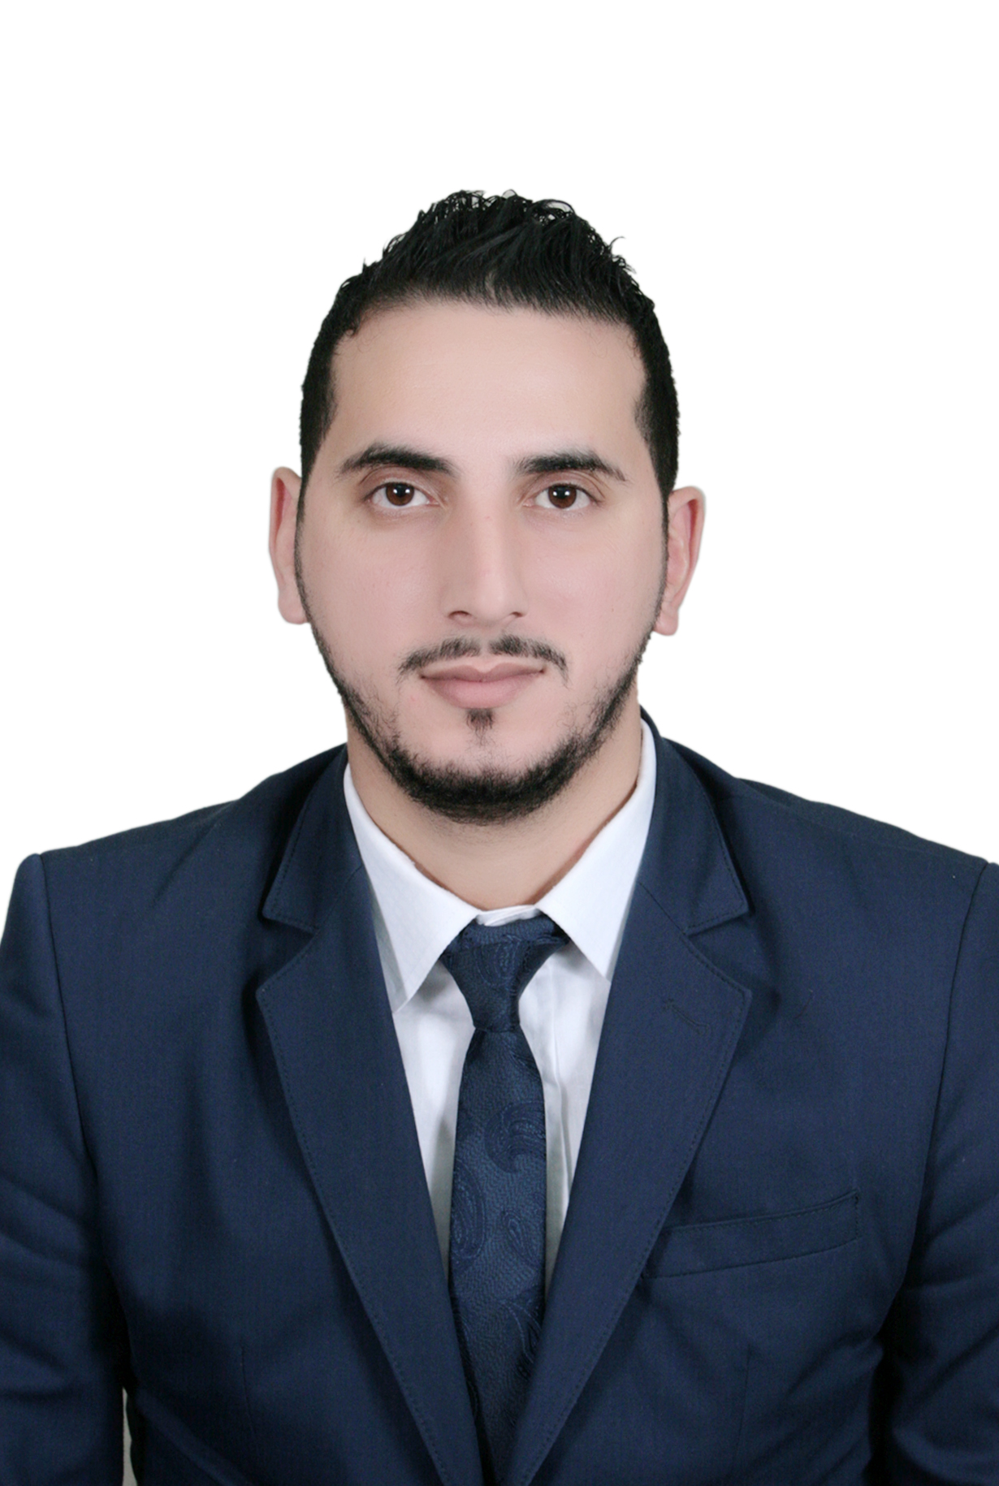
Yassine Zouak
Doha - Qatar
Mobile: +97430030193
+97477263495
Email: yassinzowa9@Gmail.com
Valid UK Visa ©

Career Summary

- Self-motivated and devoted management professional with Six years of experience in Travel and Tourism sector.
- Extensive experienced career in the traveling field with organizational skills and professionalism.
- Expertise in all aspects of travel, tourism and catering.
- Experience of managing several tour events and special travel programs.
- Pleasant, outgoing and responsive personality.
- Ability to adapt myself in any environment. Impact.
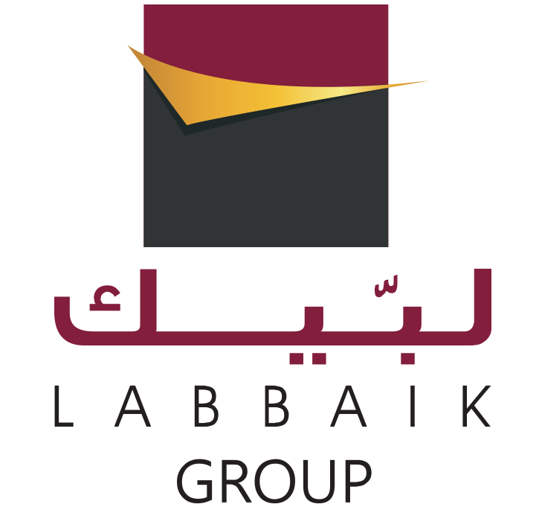
Work Experience

2013 –2015 Labbaik Travel & Tourism Doha, Qatar
Head of tourism Department

My career was as showing in the next points

- Preparing quotations & Organizing (Family, Youth, Honeymoon and corporation groups travel packages) to Malaysia, Turkey, The Maldives, Dubai, Thailand, Egypt, Morocco,Bosnia ,Eastern & Western Europe ..
- Dealing with international tour operators and DMCs whether online or Offline
- Handling hotel bookings, Airline ticketing, Transfers, and Ground Services,
- Building and selling Umrah packages (Visa, Hotel bookings, Tickets and Airport transfer)
- Contact and make business cooperation with international hospitality corporations, tourism suppliers, Tour Operators around the world.
- Organising International travel exhibitions Like Dubai ATM,WTM.ITB ,to open new destinations and enhance our relation with the international tour operators.
- Travelling with our Groups As a tour Leader to couple Of Destinations (Turkey,Western Europe-eastern Europe).
- Planning and manage digital marketing campaigns.
- Managing, Training & Supervising sales and customer services staff.

2009 –2012 Mazagan Beach Resort El Jadida , Morocco
Guest service Agent

My career was as showing in the next points

- Meeting and handling VIPS bookings.
- Handling guests Check In and Out.
- Selecting guest rooms based on their bookings.
- Help and assist guests in their needs.
- Gusts data entry and preparing their bookings papers.
- Answering phones & dealing with guests complaints.

2007 –2009 C’ OOPERATIVE TRAVEL Ste Tetouan, Morocco
Customer services Advisor

My career was as showing in the next points

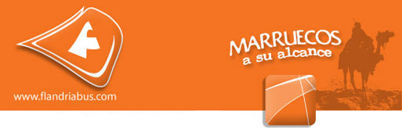
- Making the customer aware of new offers, discounts, schemes etc
- Making effective and pleasant communication with the customer
- Making the customer aware of the practical use of products
- Arranging for appropriate display of goods.
- Recognizing the frequent customers and their buying behavior
- Communicating favourable image of the organization as a whole.

Education and Qualifications

Faculty of literal sciences (Abdelmalik Saadi) Holds a DEUG in English Studies

Professional Development

- Management Development Programme | - Effective Man Management
- Marketing Management | - Social media marketing, Building plans
- Presentation Skills | - Team Building, Hotel booking, Sales

IT Skills

- Word, Excel, Access, PowerPoint, Internet and Outlook

- Micros, Opera, Amadeus, Oxygen,

Courses / Training Accomplished

- Diploma in tourism and Hospitality Scientific &professional institute of Rabat Rabat , Morocco
- Diploma in Spanish language Cervantes Institute Of Tetouan (DELE) Tetouan , Morocco
- Luxury Attitude Mazagan Beach Resort El Jadida , Morocco
- Training Course Of hospitality Policies Mazagan Beach Resort Eljadida , Morocco
- Customer care &sales Development INWI holding Casablanca , Morocco
- Oxygen System INWI Holding Casablanca , Morocco
- Amadeus Flights Tickets bookings Amadeus Qatar Doha ,Qatar
- Amadeus Car and Hotel booking Amadeus Qatar Doha , Qatar
- Customer care and sales skills Labbaik group Doha , Qatar

Languages
- Arabic: Mother-Tongue
- English: Fluently
- French: Advanced
- Spanish: good working skills

Personal Details

Date of birth : 26/09/1984
Nationality : Moroccan
Marital Status : Single
Health : Excellent
Military Status: Postponed
Driving licence: B
Interests : Online marketing, E-Tourism, Internet, E-commerce

References Are Available On Request

