C.V

Profile

- Name: Mhd. Tarek Zaitoun
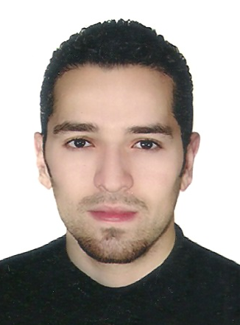
- Father Name: Ziad
- Gender: Male
- Place & Date of Birth: Damascus, 1/1/1990
- Nationality: Syrian.
- Marital Status: Single.
- Phones: 00963 947777832
- E-mail: tarek924@hotmail.com
- Current Address: Damascus.

Qualification:

- Certificate of the Tourism institute, Ticketing section, ministry of tourism, Damascus.
- ICDL Computer course, New Horizon Center, Damascus.
- Certificates of: Galileo Terminal Systems, and AMADEUS.
- Certified to work on the secretary accounting software

Experiences:

- Ticketing Employee: RAMITA for tourism company, for4 years.

SKILLS

- Hardworking and able to work under pressure.
- Self-confident, flexible and able to develop my skills quickly and creatively.
- Ability to work with team work.

Languages:

- Arabic: Mother Tongue.
- English: Good .

Notes:

- Available upon request.
- I have Driving license.

