**CURRICULUM VITAE**

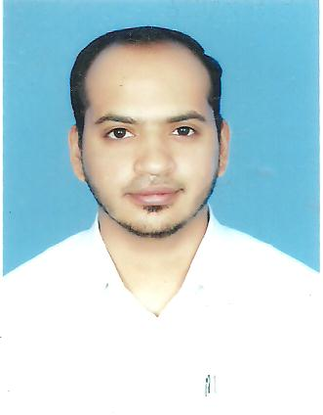

**MUHAMMAD ASIF**

** Bur Dubai, United Arab Emirates**

** +971 564371621 / +923217774716**

**dryocean87@gmail.com**

**Career Objective**

With an extensive 13-years background in sales and customer services. I am seeking a position in which I can show and justify with my Abilities. I am hoping to acquire a challenging position where I make use of my extensive experience in the field to handle staff recruitment and promote employee relations to increase the overall effectiveness of your company’s workforce. To join an interactive organization that offers me a constructive workplace for communicating and interacting with customers and people.

**Educational Qualification**

|  |  |
| --- | --- |
| **COURSE** | **COLLEGE / UNIVERSITY** |
| **B.A.(Bachelor of Arts )** | **University of The Punjab, Lahore, Pakistan** |

**Work Experience**

1. **Company : Sky Vision Travels Pvt Ltd Lahore, Pakistan**

**Designation : Business Development Manager**

**Period : Aug-2016 To Dec-2016**

1. **Company : IPC (International Painting Competition) Pakistan**

**Designation : Business Development Manager**

**Period : Jan-2014 To Jul-2016**

1. **Company : TRG (The Resource Group) in Lahore, Pakistan**

**Designation : Sr. Customer Support Executive**

**Period : Dec-2008 To Dec-2013**

1. **Company : ABN AMBRO BANK Ltd (Formally known as FYSAL BANK) in Lahore, Pakistan**

**Designation : Personal Banking Consultant**

**Period : Sep-2006 To Nov-2008**

1. **Company : PAKISTAN AVAIATION in Lahore, Pakistan**

**Designation : Business Executive**

**Period : Mar-2003 To Sep-2006**

**SKILLS**

* **Proficient with Microsoft Word, Excel, and PowerPoint**
* **Able to think and solve problems in a logical way**
* **Ability to take on new challenges and easily adaptable**
* **Knowing the strengths and skills I have and having the confidence to put these across through my work**
* **Highly motivated and enthusiastic in pursuing tasks**
* **Good understanding of numerical data, statistics and graphs**

**Personal & Passport Details**

* **Date of birth : 04/March/1987**
* **Nationality : Pakistani**
* **Gender : male**
* **Marital Status : Single**
* **Languages Known : English &Hindi**
* **Visa Status : Visit Visa (Expiry on : 21th March 2017 )**

**DECLARATION**

**I hereby declare that all the above statements all true and correct in my knowledge ad belief and the information given in the CV is accurate and fair reflection of my abilities.**

**Yours faithfully**

**Place: Dubai MUHAMMAD ASIF**