Marc Atallah 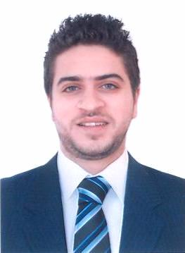

Personal Information

Gender : Male
Marital status : Single
Date/Place of birth : August 17, 1986 – Nahr Ibrahim
Nationality : Lebanese
Telephone : 09-44 07 15
Mobile : 71-79 70 70
E-mail : atallah.mark@gmail.com

Objective

Looking to work in a well renowned and professional company, whereby I can further enhance, contribute and develop my skills within the organization.

Educational Background

- Diploma in Business Administration, majoring in "Transportation and Logistics” – USEK – 2008

- Lebanese Baccalaureate – Sœurs des Saints-Cœurs / Kfarhbab – 2003

Professional Experience

Banking Consultant
Capital Banking Solutions – Hazmieh – Baabda [Sep 2016 till present]

Transfers and Payments Senior Officer – Transfers and Payments Unit
Byblos Bank Head Office – Voie 13 – Jbeil
[2015 till 2016]

Transfers and Payments Officer – Transfers and Payments Unit
Byblos Bank Head Office – Voie 13 – Jbeil
[2012 till 2015]

Bills Junior Officer – Bills Administration Unit
Byblos Bank Head Office – Voie 13 – Jbeil
[2010-2012]

Teller
Byblos Bank Head Office – Voie 13 – Jbeil
[2010]

Airfreight and Cross Trade Supervisor
Embassy Freight – Badaro – Beirut [2010]

Airfreight Operations
Fast Mondial and Marine – Gemmayzeh – Beirut
[2009-2010]

Waiter
Crepaway – Jounieh - Lebanon
[2004-2008]

Waiter
Century Park Hotel – Kaslik – Lebanon [2004]

Computer Skills

- Word
- Excel
- PowerPoint
- Outlook

Key Skills

- High communication skills
- Ability to deal and work with people from different backgrounds
- Organized, motivated, fast learner, reliable, capable, attentive to details, responsible, able to work under pressure
- Easily adaptable to varying situations

Language Skills

- Arabic (Native)
- French (Fluent)
- English (Fluent)

Interests & Hobbies

- Reading
- Movies
- Music
- Sports: Basketball, Football, Skiing

References

Documents and references will be forwarded upon request

