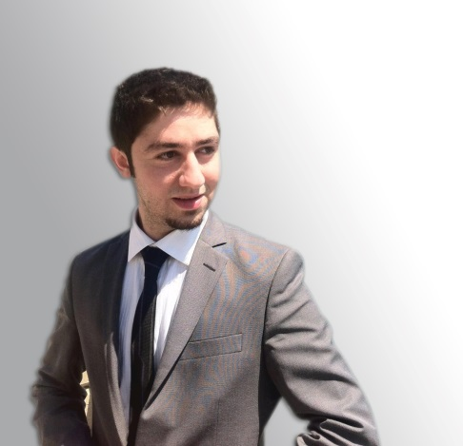Rami M. Jaber

*Birthday*: August 1, 1989

*Nationality*: Lebanese

*Address*: Tripoli, Lebanon

*Mobile*: 00961 3 506993

00971 50 8297454

*Email*: Ramijaber89@hotmail.com

**OBJECTIVE**

Seeking a full time position that would enable me to initiate a respectful career, by interacting as well as learning the industry’s know-how operations in order to implement my analytic skills & grow both professionally and personally.

**SKILLS**

* Microsoft Excel.
* Microsoft Word.
* Microsoft PowerPoint.
* Basic SPSS knowledge.
* Familiarity with balance sheets, income and financial statements.
* Data gathering for audit reports.
* Conduct preliminary surveys for audit reports.
* Creative writing, content creating.

**EDUCATION**

***Al-Manar University of Tripoli (MUT – fall 2015)***

* MBA: Masters of Business Administration in Management.

***University of Balamand (UOB – spring 2012)***

* Bachelors in Business Administration & Management: Concentration in Accounting and Auditing.

***College Des Freres Lebanon***

* Lebanese Baccalaureate - Economical sciences

|  |
| --- |
| **CERTIFICATION** |

**Morgan International (Beirut – spring 2013)**

Certified Internal Auditor: a total of eighteen lectures attended & completed at Morgan International, waiting for the suitable hands-on experience in order to sit for the tests.

|  |
| --- |
| **TRAINING** |

**MEA (spring 2012)**

As part of the Auditing course final exam, a professional auditing process took place at Middle East Airlines. An involvement that gave me, even as a student auditor, a field experience which made me familiar with how an auditing engagement is done; from understanding the industry to gathering substantial data based on questionnaires, interviews and paperwork, till reaching the ultimate purpose of conducting an auditing report that is supposed, as the auditing profession dictates, to add value to the organization being audited.

**LANGUAGES**

* Native Arabic; fluent in reading, writing and speaking.
* English: fluent in reading, writing and speaking.
* French: fluent in reading, writing and speaking.

|  |
| --- |
| **ACTIVITIES** |

* Mini-football matches organizer at Galactica Soccer Academy since 2007
* Movies fanatic
* Passionate about music
* Enthusiastic towards video gaming
* Aspiring writer
* Nature Hiking
* Member at Tripoli Entrepreneurs Club (TEC)
* Member at Alkindy social space
* Attendant at Weekly Entrepreneurs Brunch

**REFERENCES**

Available upon request