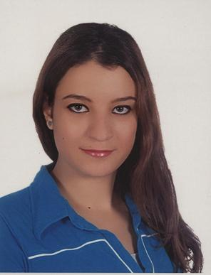
Racha Nizar Itani

Hamra, Beirut – Lebanon
Residence Address: Kuwait
Mobile: 00961 70- 919 621
Kuwait Mobile: 00965 95597760
E-mail: rachaitani88@gmail.com
Date of Birth: 01-10-1988, Ras Beirut
Nationality: Lebanese

Marital Status: Single

Objectives
Looking for a full-time job in a suitable organization that offers good opportunities for career development

Career History

- Touristic Enterprises Company (TEC) - Kuwait
- Kuwait Towers:
Hostesses & Guest Relations Manager
January 18th, 2016 – Present

- Intercontinental Hotels Group – IHG

- Crowne Plaza Beirut–Hamra Street
CORPORATE SALES EXECUTIVE
October 10th, 2015 – December 22nd, 2015

- Intercontinental Kuala Lumpur - Malaysia
(Task Force /Secondment)
Middle East Sales Manager – Middle East Ambassadors Contact Person Handling their Private Events, National Days Celebration, Special Catering Requests
July 13th, 2015 – till October 09th, 2015

- Crowne Plaza Beirut–Hamra Street
BANQUET SALES EXECUTIVE - CROWNE MEETING DIRECTOR
November 2014 – October 10th, 2015
- Crowne Plaza Beirut–Hamra Street
SALES COORDINATOR – DEPARTMENTAL TRAINER

General Manager Personal Assistant

October 2012 – October 2014

- Holiday Inn Beirut-Dunes –Verdun, Beirut
RECEPTION AGENT September 2011 – September 2012

- Holiday Inn Beirut-Dunes –Verdun, Beirut
HOUSEKEEPING SUPERVISOR June 2011 – August 2011

- Cocteau Brasserie – Achrafieh, Beirut
HOSTESS June 2010 – September 2010

- AUL University – Hamra, Beirut
ASSISTANT in the Marketing Department Fall 2009 – Spring 2010

- Al-Tayer Group (Insignia Fashion Department)- UAE
SALES EXECUTIVE November 2008 – June 2009

- Gefinor Rotana Hotel – Hamra, Beirut
HOSTESS & WAITRESS June – July 2006

Academic Qualifications

- AUL University – Hamra, Beirut
BA in Business & Hospitality Management graduated in Spring 2012

- Zahia Kaddoura High School – Beirut
Lebanese Baccalaureate in Sociology & Economics 2008

Personal Skills

Computer Skills: Microsoft Office (Word, Excel, Power Point, Outlook)
Internet; Opera System; POS; Micro’s ; Fidelio

Language Skills: Arabic, English, French

Hobbies: Singing, Dancing, Sports

References available upon request

