Ramy Lakdar  Mejdlaya-Zgharta  Tel : 71708203  Email : ramylakdar@gmail.com  22, single | 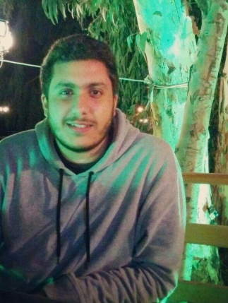

EXPERIENCES

november 2012-july 2014 | Private teaching – classes of brevet elementary and high school
July 2014 internship with WAR CHILD organization

September 2015 internship with SGBL bank

EDUCATION

1997 - 2012 | Baccalaureate, economy and sociology – “Ecole Nationale Grecque Orthodoxe”  Tripoli-Zahiria.

End 2012 – 2016 | Business administration – banking finance  Bachelor degree  Lebanese university faculty of economical science and management of financial institutions.

LANGUAGE AND COMPUTER

English, french, arabic | (fluent)

Computer | Office: documents controller (excel, word, power point…)  HTML, command prompt, android.

INTERESTS

Camping, hiking, scouts, cinema, swimming, cooking and more

