Curriculum VITAE

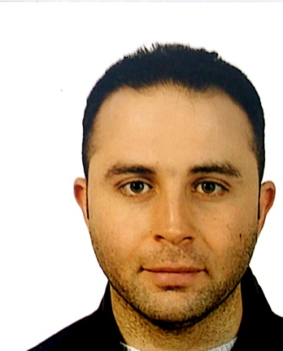Mohammed Hilal habli

Place of birth: Saida – Lebanon

Date of Birth: 25-06-1985

Status: Married

Nationality: Lebanese

Address in Lebanon: Saida – Lebanon

Contact information

Mobile KSA: +966535581047

Mobile Lebanon: +96170605680

Email Address: [Mohhabli9@gmail.com](mailto:Mohhabli9@gmail.com)

Objectives

Seeking a challenging position in the travel and tourism domain where my professional

And practical experience will be fully utilized.

Career profile

Proven record of reliability and responsibility. Remain calm and professional throughout critical cases. Strong analytical skills, capable of assessing conditions and implementing appropriate intervention.

Resourceful problem solver capable of implementing solutions to complex problems. Possess special sensitivity to meeting diverse needs in varied situations.

Education and experiences

Bachelor in Travel and Tourism Management – Lebanese university, Faculty of Tourism and Hospitality Management, Beirut – Lebanon. (2009)

First year Bachelor Geography sciences, Lebanese University, Faculty of Literature and Humanity sciences, Beirut – Lebanon (2008).

Courses in airport management, airport safety and security, passenger services, dangerous goods familiarization, DCS check in (Gaetan system). (2007)

Courses in Windows – Word – Excel- Power point, internet and typing, Compulando center, Beirut – Lebanon. (2004)

Third secondary, life sciences section, Saida official school for boys, Saida Lebanon. (2004)

Professional experiences:

Saudi Oger ltd, section head travel office- Head Office, Riyadh – Kingdom of Saudi Arabia and still in my position up to this moment. (2016)

Middle east airlines- Air Liban, Rafic Hariri international airport- Beirut, passenger handling services ( Counter check in, immigration facilities, gate boarding and announcement, station control…etc. ( 2009)

Reservation agent at Orchid beach and resort, Beirut- Lebanon (Summer 2008)

Paid training at Golden holidays for travel and tourism and it last for 4 months.

Other skills:

Hard worker, team worker, representative, self-motivated and target driven.

Languages:

Fluent and excellent in Arabic and English, good in French.

References:

It will be available upon request.