MISBAH FATEMA HUSSAIN  AlBaqer4, Flat No. 904, Al Tawun,Sharjah, UAE P.O.Box 82153|M: 0558369829 misbah.hussain7@gmail.com | 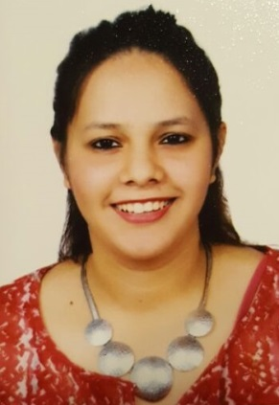
Executive Profile
- Self-motivated and devoted management professional with nine years of experience in Travel and Tourism sector.
- Extensive experienced career in the traveling field with organizational skills and professionalism.
- Expertise in all aspects of travel, tourism and catering.
- Expertise in handling groups.
- Pleasant, outgoing and responsive personality.
- Expertise in developing tour packages and plan travel.
- Ability to adapt myself in any environment
Skill Highlights
- Self-Motivated Business operations organization
- Customer Oriented Client account management
- Time Management Hard Worker
- Vendor Negotiations Fast Leaner
Professional Experience
Senior Executive
Reckon Travels & Holidays -Mumbai Maharashtra May 2009-Apr 2016
- Arranging flights, insurance and accommodation.
- Using a booking system to secure holidays.
- Collecting and processing payments.
- Advising clients on travel arrangements, e.g. visas and passports.
- Sending out tickets to clients.
- Keeping clients up to date with any changes.
- Dealing with complaints or refunds
- Maintaining the data of customers.
- Making payment s to suppliers for hotel packages
- Escorted Groups to Dubai ,Singapore and Malaysia.

Executive

Al United Travel Links and Pvt Ltd Nov 2007-May 2009
- Arranging flights, insurance
- Using a booking system to secure ticketing.(Amadeus)
- Handling Rent a Car within India for tourist and co-operates
Education
Bachelor of Arts - Literature Apr 2010
KC College-MUMBAI, MAHARSHTRA -INDIA
Languages
- English
- Sign Language
- Urdu
- Hindi
- Gujarati
- Arabic only read & write
Certifications
- Aussie Specialist in the year 2010
- Canada Specialist in the year 2010
- Kiwi Specialist in the year 2010
- Dubai Specialist in the year 2011
- Oman Specialist in the year 2011
- Kenya Specialist in the year 2013
- Malaysia Specialist in the year 2013
- Certified France Travel Agent in the year 2013
- Completed I Know Europe Certification Programme in the year 2013
- Star Cruise Specialist in the year 2015
Achievements
- Recognized for managing successful trips with "Excellency" award.
Personal Details
- Date of Birth: 11thDec 1989
- Passport No.: J-1738796
- Visa Status: Residence Visa
- Nationality: Indian
- Marital Status: Married
- Driving License: Applied

