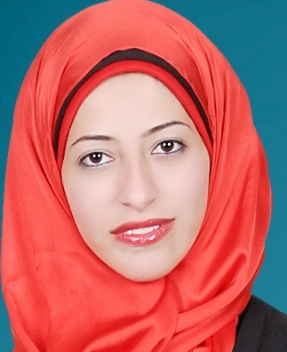
Safaa Marzouk Ali
Manshetelkanater
Giza
Egypt
01014907616
E-mail: safaamarzouk@yahoo.com

WORK EXPERIENCE

Reservation Specialist(Memphis Tours Egypt) from April ,2015 to present
Dealing with all hotels booking systems.
o Handle inbound and outbound holidays packages for group and individual.
o Using market research information to guide decisions
o Providing pricing information
o Marketing holidays to clients via travel agents, websites, brochures.
o Handling bookings, invoicing and issuing of vouchers
o Providing general and specific advice about different travel destinations
o Drawing up complicated travel itineraries and ensuring that all the needs of the customers are met
o Making arrangements for transport, accommodation, tours, and activities
o Planning and advertising different promotions
o Making alternative arrangements for customers who have had their trips interrupted by unforeseen issues
o Evaluating customers’ holidays and issuing appropriate feedback forms

Tour operator (Kemet Travel)from Feb to December 2014
- Manage, plan and operate inbound tours
- Make all Hotels reservations
- Reserve means of transportation preferred and any other activities can be preformed.
- Follow up all new tourism spots and hotel to offer the best services
- Web Site administration

Objective
Seeking a Challenging position that will utilize my previous work experience, academic background and develop my Skills In Tourism,
Education
Bachelor’s Degree in Tourism, Faculty of Tourism and Hotel Management, Helwan University, July 2012.
Overall grade: Excellent Overall percentage: 88.5%

courses
  - English Course, Level
Berlitz English institute- Summer 2011
  - Korean Course,
KOICA (Korean International Cooperation Agency)- Summer 2012
Topic Test, 2012

internships
International Cairo Airport
- Trained In The Transit Department
- Developed a sense of teamwork
- Introduced to Aviation System
- Introduced to Ticketing and quick Visa

Elkarnak for Travel and Duty free company
- Trained In inbound Department
- Receive guest's requests
- Open operation file
- Make all reservation needed
- Solve any problem face
- Follow them till backing home country
Skills
- Language:
Arabic | Mother Tongue
English | Very good
French  Korean | Fair  Very good

- Computer Skills: Microsoft Office (Advanced (

personal information
Nationality Egyptian

Interests and activities
*Reading * listening music

references are available upon request

