Curriculum Vitae

Personal information 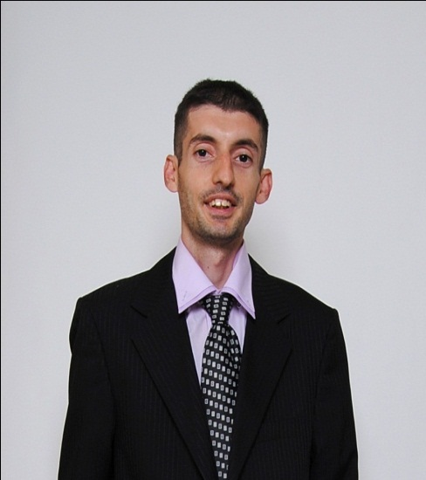

* Name: Bojan
* Surname: Tomic
* Date of birth: 1st April 1985
* Place of birth: Krusevac , Republic of Serbia
* Address: Al Barshia, Emerald Court building

Dubai, UAE

* Phone 0505823520
* E-mail [bokiis85@gmail.com](mailto:bokiis85@gmail.com)
* Marital status: Single

**Resume**

Highly qualified and trained worker, with a lot of work experience and a lot of enthusiasm, for whom there are no obstacles to respond any assigned task. Very creative, communicative, oriented towards team work, friendly and always willing to help. Beside that I’m analytical and problem solver, with „diplomatic“ skills and great listener. Open minded and versatile. Above all, always love job I do, and that’s the key I choose desire work. At the moment, I am looking into the future and I would like to continue my already successful career in your professional team. I would like to gain new experiences, meet your people and improve myself, professionally and personally. Most of all I like opportunities your country offer, it’s language and culture, that’s why I’m really glad because of my decision to come to live here, reaching new life experience.

**Work experience**

* 11/2015 – present

**Al Jaber Optical – Sales consultant**

Customer service, sales and administration

Reference: Firas Saab, Training/Area manager

* 09/2014 – 11/2015

**Avantura Park – Key Account Manager cum Marketing/PR**

Marketing strategy and business development; Community management; Customer and public relations; Event and social media management; Office management and recruitment; Sales

Reference: Dragana Gagic, Marketing manager

* 06/2011 – 09/2014

**BalkanInterfest agency for leisure and marketing – Marketing/Sales Assistant**

Customer relationship management and sales; Marketing and PR promotions; Event organization and coordination; Outdoor activities and tour coordination; Social media management and media campaign

Reference: Marija Maricic, CR Manager

* 09/2008 – 03/2011

**Wizantiana agency – Office administrator**

Marketing plan realization; Media analysis – social media; PR - event management; HR manager assistant, recruitment and trainings

Reference: Djurdjija Radojicic, Development manager

**EDUCATION**

* Faculty of political science – Asian studies

Master in international affairs, economy and cultural diplomacy

(2012 – 2015)

* Philosophy faculty – Belgrade university

Bachelor in History

(2004 – 2009)

* High School: School of Economics 4 years

(2000 - 2004)

**Languages: Computer skills:**

English – Fluent (oral and written) Advanced in MS Office

Spanish – Intermediate Advanced in social applications

Turkish – Basic CRM applications; ORION

Other skills/experiences/interests:

* **Writing** (journalism, publications, creative, copywriting, articles, blogger)
* **Dancing** (folk dancer for more than 15 years, salsa)
* **Trainings** (seminars – participated and organized, workshops, summits)
* **Social activities** (volunteer work and NGO – founder)
* **Sport and recreation** (football and volleyball in a free time with friends)