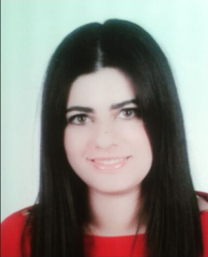 **MARIA-LENA BERGE KISSOYAN**

GEMMAYZEH, PASTEUR STREET, BEIRUT, LEBANON

PHONE 76146901 /01446544

**OBJECTIVE:** ______________________________________________________

*To contribute to the overall success of a dynamic and growth oriented company, and participate to the achievement of corporate objectives.*

**PERSONAL INFROMATION**: __________________________________________

* Nationality: Lebanese
* Age: 22
* Gender: Female
* Place of Birth: Beirut, Lebanon
* Email: [mkissoyan@students.haigazian.edu.lb](mailto:mkissoyan@students.haigazian.edu.lb)

**EDUCATION**_______________________________________________________

* 2016**:B.B.A**. from Haigazian University - Kantari, Beirut, Lebanon
* 2004-Present National Conservatory of Music, Beirut, Lebanon

Persuing a baccalaureate degree in Piano

* 1996-2011 : Armenian Evangelical Central High School

Lebanese Official Baccalaureate in Life Sciences

* Graduated in July 2011 with honors

**AWARDS RECEIVED**_________________________________________________

* **2016**” Best Project Execution Certificate in Project Management of Senior Seminar
* **2013**”,**2014**” & **2015**”Music Awards from Haigazian University
* **2011**” Honors from AECHS
* **2009**” Position Paper Award from LAU-Model United Nations

In UNHCR Committee of Nepal

* **2008**” Second Prize in Lions Piano competition-Safadi Center-Tripoli
* Fabriano Art Awards

**LANGUAGES**______________________________________________________

English, Arabic, Armenian, French

**WORK EXPERIENCE**_________________________________________________

March 2016-Present: Assistant Coordinator in Simon Electric

2014-2015: Private Piano teacher

2013: Music teacher at Saints Coeur Sioufi

2012: Music Teacher at Armenian Evangelical College

July 2011- Sep.2011: Assistant Accountant t in Zoran

2010-2016: Private Piano Teacher

**INTERNSHIP** __________________________________________

Summer 2014-Internship at Central Bank of Lebanon

**VOLUNTEER EXPERIENCE**____________________________________________

Volunteer pianist in AECHS from 2007-2011

**EXTRACURRICULAR ACTIVITIES**_______________________________________

* HU Music Club
* HU Herald Club
* HU Badminton Club

**HOBBIES**_________________________________________________________

Sports, Biking, badminton, reading & piano

**REFERENCES**______________________________________________________ Excellent references available upon request