NAZIA BANU 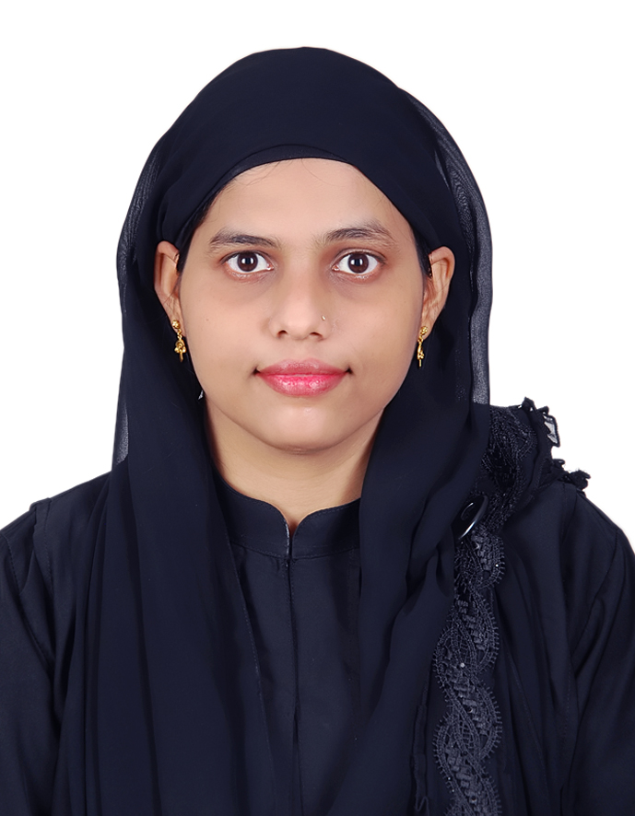

E-mail: naazhiba@rediffmail.com
Contacts : 00971502540615/ 00971566076782

OBJECTIVE

To achieve a synergy between my individual career aspirations and those of my organization and to that the learning process in continuous to help me and my organization grow.

SKILLSETS

- Good in Problem Resolving, Customer Service & Communications.
- Fluent in English, Hindi and Marathi languages both Speaking & Writing.
- Excellent in providing tuitions to School Children’s & Training New Trainees.
- Self-motivated professional with strong problem solving & organizational abilities.
- Result-oriented with analytical skills & a drive to succeed.
- Effective team player with strong interpersonal, communication & presentation skills.

ASSETS

- Ability to grasp new ideas and grow in knowledge.
- Able to work well with others.

COMPUTER PLATFORMS WORKED ON

- Windows Xp, Windows 7
- MS word , Excel , PowerPoint
- Internet Explorer , Outlook Express, Fire Fox

EXPERIENCE

- Organization: Nivalink Consultancy Services Pvt. Ltd (Mumbai, India)
Position: Travel Executive
Period: April 2006-October 2007

- Worked as a Travel Consultant with Nivalink Consultancy Services Pvt. Ltd. (Mumbai) (www.nivalink.com) Job Profile Includes Taking (Tele & Email) Enquiries for Hotels / Resorts bookings all over India, training juniors & new-comers.
- Communicating with Royal Customer to resolve their queries.
- Training & feedback for new joiners.
- Ensuring optimum Service Level

- Organization: Airlink Tours & Travels Pvt Ltd. (Mumbai, India)
Position: Travel Executive & Customer Service
Period: October 2007-April 2008

- Communicating with travel agencies for air tickets car rentals bookings.
- Booking and Reservation of Air travel Tickets
- Also direct contact with the resort and the hotels for reservations.
- Tie – ups with the co-operate companies for group bookings (in case of conferences)

- Organization: Paradise Isle Beach Resort, (Malpe-Karnataka-India)
Position: Front Office Executive
Period: June 2008 – January 2009

- Was working as front office executive Job Profile Includes Taking (Tele & Email) Enquiries for Resorts bookings, training juniors & new-comers.

EDUCATION

- Graduated with Bachelor of Arts(April 2007 –2008) Successfully in Mumbai (University of Mumbai)
- 2004-2005 H.S.C Mumbai University (SNDT College).
- 2001-2002 S.S.C Maharashtra Board (Fatima High School).

ADDITIONAL QUALIFICATIONS

- Diploma in Travel, Tourism & Ticketing from IITC (Ghatkopar, Mumbai) along with CRS system (Amedeus & Gelileo).

PERSONAL PROFILE

Date of Birth: 28th March 1987
Sex: Female
Nationality: Indian
Martial Status: Married
Visa Status : Tourist Visa
Visa Validity : 28 May 2016

References :

Rizwan Nazeer Sheikh, System Analyst, Canadian University Dubai. 0555543638
Parveen Riyaz Sheikh, Team Lead in Emirates Islamic Bank, 050 8816739

