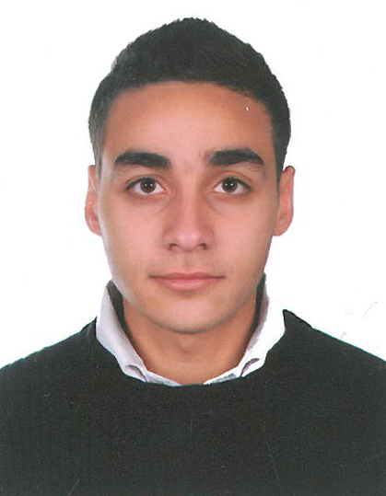
Michel Slaiby
Business Administration

- Personal Data:

- Full Name : Michel Rony Slaiby
- Date & Place of Birth : September 23, 1993 , Ghazir – Lebanon
- Mailing Address : Slaiby BLDG , Al Bassatin street , Ghazir , Mount Lebanon
- Mobile : (+961) 70 153423 /Email : Michel-slaiby@outlook.com

- Education:

2011- 2015 The Holy Spirit University of Kaslik , Lebanon
Bachelor in Business Administration
Major: Management

2007 -2010 Official High School Ghazir , Lebanon
Secondary (Sociology Economy)

- Experience:

2015-present Bar Supervisor, Showcase Jounieh
- Maintaining the inventory’s minimum stock quantities
- Preparing cash drawers upon request

2012-2013 Assistant Supervisor, Publicity Resort
- Planning and Coordinating menus
- Responding to customer complaints

2010-2012 Assistant Manager, Edde Sands Resort
- Handling managing responsibilities ( Sales , Reports )
- Recruiting , trainings and motivating staffs

- Special Skills:

Language Speaking Writing Reading
Arabic Excellent Excellent Excellent
French Good Good Good
English Good Good Good

Computer Literacy: Word, Excel, PowerPoint, Internet (navigation, research), Social Networking (Facebook, Twitter, Google +), LinkedIn

