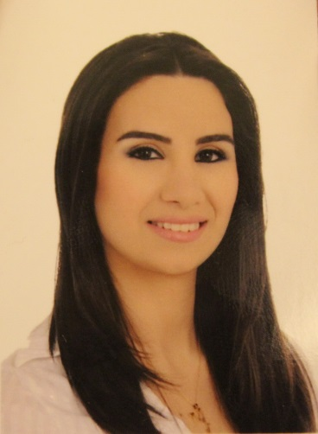Mariane Salem Bteich– LEBANESE – 1990

Mobile: (+ 961) 70 72 42 72

Phone : (+ 961) 09 22 44 11

E-mail :[mariane_bteich@live.com](mailto:mariane_bteich@live.com)

Home:Zouk Mikael – Saint John st.

*Objective (HR Associate)*

To hold a challenging position in a multinational enterprise where I can utilize my work experience and educational background. To be an asset to the firm, and at the same time, to improve the experience I have acquired in this domain.

*Professional experience*

* HR Administrator at Loisir Distribution sarl July 2014 till present
* Assistant HR Manager at Loisir Distribution sarl October 2010 till June 2014
* **Job description:** Acting the HR functions. Following the employment process. Calculating and organizing the financial input of branches (11 branches/200 employees).
* **Job duties** : **HR**

1. Recruitment
2. Payroll
3. NSSF documents
4. Holidays and Annual Leaves
5. Daily attendance
6. Follow up: Name tag, Uniform…
7. Files Control
8. Behavioral and Technical trainings.

**Administrative**

1. Daily financial Follow up (Cash, visa cards, checks).
2. Managing the pity cash box, for special demands.

* Assistant Manager and Cashier at Sport ET Loisir shop May 2010 – Oct. 2010
* Salesperson at STRAIGHT boutique (kaslik) Oct. 2008 – May 2010
* Waitress at Cyan Beach Resort (kaslik) Summer 2008

*Educational Background*

* *License “Psychologie de Travail” 2012 -2013*

*Lebanese university – Fanar*

* *Lebanese Baccaloriate in Letters and humanities 2007 – 2008*

Notre Dame De Louaizé – ZoukMosbeh

*Qualifications and skills*

Organised, results-oriented, motivated, a high degree of commitment and a willingness to learn new skills.

* **Computer Knowledge**:Internet, Microsoft Word, Excel, Power Point,Bioca Attendance, Dolphin (Payroll).
* **Languages skills**: Arabic (mother tongue), English, French (Reading, written and spoken)

*Personal Information*

Birth: 01January1990 – Faraya, Kesserwein

Nationality: Lebanese

Marital Status: Engaged

Activities andInterests: Dancing, Music, Sport …

*Reference*

Christiane Awad (HR Manager at Loisir Distribution sarl ) 71/ 173 383

Jack Khalil (Owner of Straight boutique) 03/ 350 450