**Angelique K. Mahfouz**

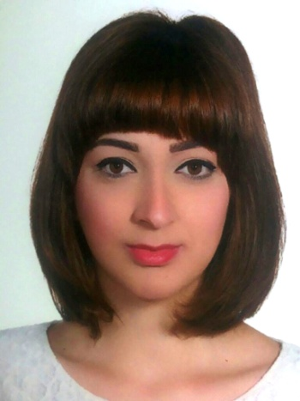

T e l : 01/877896 - 07/230224

Mobile : 76/320079

E-mail : [Mahfouz.angelique@hotmail.com](mailto:Mahfouz.angelique@hotmail.com)

Address :- Biakout , Sayde St , Hani Obeid Bldg , 5th Floor

-Lebaa-Jezzine , neighborhood “Al Taamir” in front of lebaa club

**Bio-Data**

Date of birth : 27/10/1988

Nationality : Lebanese

**Hobbies:**

* Music
* Sport ( Hiking, bicycling)
* reading

**EDUCATION :**

2010-2011 : Bachelor degree in geography / Lebanese university

2005-2006 : High School Certificate SE/ Socio economy

**Training And Certificates :**

1. **Basic Travel Document Awareness Course At Mea Including :**

* Schengen- and UK Documents
* Passenger Assessment and Impostors

1. **Basic Passenger Services Training And Development Course At Mea**
2. **Altea Dcs Customer Management Course At Mea**
3. **Certificate Of Completion The Fourth And Fifth Course In English At American Language Center**

**Work Experience:**

* May 2015 - Till Present : Passenger services at Middle East Airlines / Meag : Ground Handling
* September 2011 - May 2015 : Assistant accountant at Abou Khalil Furniture Company
* July 2010 - November 2010 : Data entry at Data Structuring Company

**Skills:**

* Dolphin : Account / Stock
* Bird : Account / Stock
* Computer Skills: Knowledge in computer programs excel, word, powerpoint

**Languages:**

French, English, Arabic (Reading, Speaking, Writing)