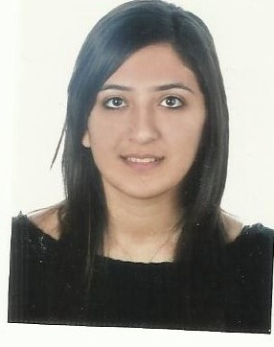

**Laura Elias Assal**

**Personal Informations**

Nationality: Lebanese   
Date of Birth: 19 October 1991

Address: Mina Street next to St. George Church   
Batroun, North Lebanon

Mobile: 70 509770

Email: [laurassal-91@hotmail.com](mailto:laurassal-91@hotmail.com)

**Career Objectives**

To Utilize and build up on the professional capabilities through continuous contribution and dedication by delivering my duties to the fullest to reach responsible position in future.

**Experience in Brief**

8 years of experience   
Front Office and Reservation agent   
Housekeeping supervisor   
F&B experienced

**Education**

September 2014 - Present

Masters of Business Administration (MBA) Human Resources   
 Concentration  
 American University of Technology, Halat Campus

September 2010 - February 2014

Bachelor of Business Administration (BBA) International Hospitality Management concentration

American University of Culture and Education, Koura Campus.

October 2007 - June 2010

BacTechniques (BT3) in Hospitality Management

Institut Freddy Attallah,Kafaraaka, Al Koura

**Experiences**

May 2015 – Present Owner and manager of “Tout de Sweet” dessert   
 restaurant – Batroun -

August 2014 – May 2015 Member of the pre-opening and opening team of   
 “ L’auberge de la mer” Batroun boutique hotel 4  
 stars   
 Assistant Manager

February 25- April 25 2014 Trainee at “Nakhal” Travel Agency – Jounieh-

June 2012 – July 2013 Cashier at “Bonita Bay”

Thoum, Batroun

June 2011 – September 2011 Front Office Agent at “San Stephano Resort”

Batroun

June 2007 – September 2009 Food and Beverage waitress

“Le Marin” Restaurant, Batroun

**Skills**

Languages: Arabic mother tongue

English excellent spoken and written

French good spoken and written

Good communication skills

Calm, efficient and organised

**References**

Available upon request