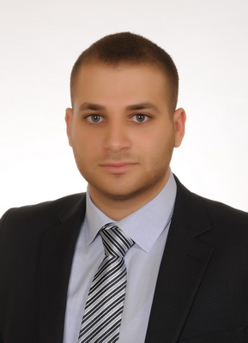
Farah Building, 4 Floor, Mar Elias, | Telephone : (+961) 01 310 699
Khalil Khatab Street, Beirut, Lebanon. | Mobile : (+961) 03 117 115
 | Email address : jaber.hassan@live.com

Hassan Jaber

PERSONAL INFORMATION
Nationality : Lebanese
Date of Birth : February 20,1992
Gender : Male
Marital Status: Single
Place of birth : Nabatieh

EDUCATION

2013 – 2014 : Saint Joseph University - Beirut, Lebanon.
First year Master degree in Management, Entrepreneurship and new Technologies.

2010 – 2013 : Saint Joseph University- Beirut, Lebanon.
Bachelor degree in Business Administration.

2012 : Georgetown University - Washington, USA.
Certificate of English language proficiency.

2007 – 2010 : College Saint Elie Btina - Beirut, Lebanon.
Certificate of the Lebanese baccalaureate in Life Sciences.

1995 – 2007 : Lycée Franco-Libanais Verdun - Beirut, Lebanon.
Certificate of the Lebanese Secondary Education (Brevet).

EXPERIENCE

July 2014 – August 2015 : Working at “CEGAP s.a.”.
Oloumi, Libreville, Gabon.
13 month
Client Account Manager (Debt), Administration, Accounting, Cashier, Banks accounts manager, Customers service, Employees accounts/salary manager, Inventory control and Daily Income Statement, Import documents, Negotiating with suppliers and Email.

April 2014 – June 2014 : Training at “Audit 768 s.a.r.l.”.
Bechara El Khoury, Beirut, Lebanon.
3 month
Training: Data entry EDM accounting software, Account reconciliations, Filling system, Stock control.
(Junior Accountant Trainee).

February 2014 – March 2014 : Training at “Société Générale de Banque au Liban”.
Mar Elias branch, Beirut, Lebanon.
2 month
Training: Reception face to face, General banking culture, Regularity and conformity of banking, Fight against money laundering and terrorist financing, ICBS, Simple product SGBL, SCOR & MOPA, Approach to youth, Count and examine money.
(Teller).

October 2013 – January 2014 : Training at “Wood Plus s.a.r.l.”.
Sin El Fil, Beirut, Lebanon.
4 month
(Accounting, Filing, Data entry, Customer Service, Supervising).

August 2013 : Training at “Premium Company Capital”.
Nabatieh, Lebanon.
1 month
(Forex, and Data Entry).

July 2012 - August 2012 : Training at “FRANSABANK”.
Salim Sleim Branch, Beirut, Lebanon.
2 month
(Teller and Retail Banking Operations).

COMPUTER SKILLS

MS Office (Word, Excel, Access and PowerPoint), Internet Navigation, Visual Basic, ICBS, EDM accounting software, Html codes and SAGE Business Software.

LANGUAGES

Languages | Oral | Written
Arabic | Excellent | Excellent
French | Excellent | Excellent
English | Excellent | Excellent

HOBBIES AND INTERESTS

Photography, Travelling, Jogging, Reading, Swimming, Tennis and Ping-Pong.

REFERENCES

Available upon request.

