**Alain Raymond Hajjar**

*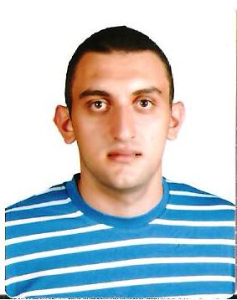****Personal Information:***

* ***Nationality:*** *Lebanese*
* ***Place of Birth:*** *Zahle, Lebanon*
* ***Date of birth:*** *25th June 1991*
* ***Sex:*** *Male*
* ***Marital status:*** *Single*
* ***E-mail:*** *hajjaralain@hotmail.com*
* ***Mobile:*** *+96170501900*

***Education:***

* *Master’s of Science in Business (Finance Speciality)* *-* Antonine University, Baabda, Lebanon. *[October 2014]*
* *Bachelor’s of Science in Business Administration -* Antonine University, Riyak, Lebanon. *[October 2012]*
* *Lebanese Bachelaureate in Science of Economics -* Sainte Famille De La Sainte Elie Zahle, Lebanon. *[June 2009]*
* Completed 8 extra courses in Management during my BA.

***Experience:***

* *Accounting Department at* ***Alfaco Trade*** *- Terbol, Beqaa, Lebanon. [February 2015 🡪 May 2015]*
* *Tax Preparer, Accounting Department at* ***Sapcoil*** *- Houch Al Oumara, Bekaa, Lebanon. [October 2014 🡪 February 2015]*
* *Sales Manager at* ***Skaff Farm Diary*** *- Houch Al Oumara, Bekaa, Lebanon [June 2014 🡪 July 2014]*
* *Training, Accounting Department at* ***Rabih Khamis’s Farm*** *- Zahle, Lebanon. [July 2012 🡪 September 2012]*
* *Internship, Accounting Department at* ***Edward Homsi’s Office*** *- Zahle, Lebanon. [July 2011 🡪 October 2011]*

***Achievements:***

* 1st place award for the Basketball Tournament of Universities in Beqaa, Lebanon with Antonine University. *[2012]*
* *Certificate of Excellence from Bank Byblos*: Entrepreneurship Course of Third Year University. *[2011]*

***Skills***:

* Microsoft Office (Excel, Word, Access)
* Adobe Photoshop
* Good Research Ability.

***Languages:*** Fluent in Arabic, English and French

***Hobbies:*** Swimming, Music, Basketball, Football, Reading and Scout.

*References/Recommendations: Available upon request.*