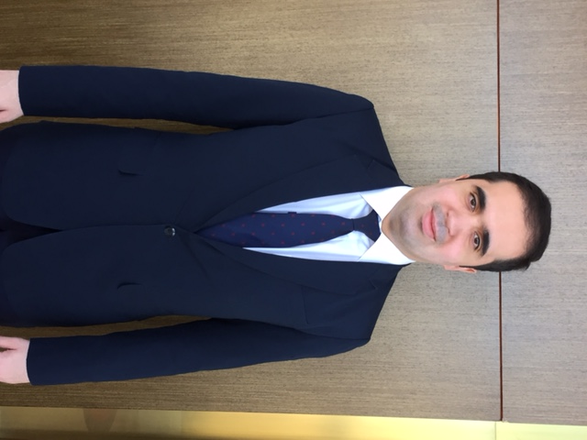

Name: Mohamed Fawaz

Current Location: Beirut, Lebanon

Nationality:Lebanese

Marital Status: Single

Height/Weight: 179cm/81kg

Date of birth: 26 November 1985

Languages Spoken: Arabic (*Mother Tongue*)

English &French*(Fluent)*

Telephone: +96176705399

E-mail: [moefaz@hotmail.com](mailto:moefaz@hotmail.com)

WORK EXPERIENCE

**The Torch Hotel Doha, Qatar June 2015 –July 2015**

Restaurant Manager (In charge of 3 outlets)

Website:[*http://www.lhw.com/hotel/The-Torch-Doha-Doha-Qatar*](http://www.lhw.com/hotel/The-Torch-Doha-Doha-Qatar)

[*http://thetorchdoha.com/*](http://thetorchdoha.com/)

Reporting to: Food and Beverage Director

**Panorama Restaurant 50th floor & the Lounge 51th (French Restaurant) February 2015 – July2015**

**PRE-OPENING & OPENING IN CHARGE**

* SOP’s preparation for service and reservation( phone and email)
* Market research for competition (menu, promotions, signature dishes, set menu, prices etc...)
* Menu suggestions and food tasting with F&B Director and Chef de cuisine and Executive chef
* Finalizing menu ( send recipe’s to cost controller for pricing and then micros request to place on the system)
* Menu and Service Training.
* Collecting needed equipment’s and prepare inventory( restaurant and bar item)
* Requesting stationary supplies
* Allocating furniture’s.
* Bar Preparation.
* Preparing restaurant layout.
* Allocating table numbers.
* Prepare reservation book according to tables numbers and capacity and timing
* Food tasting for all staff
* Managing restaurant operation
* Review and evaluate Guest feedback and menu adjustment was made based on guests feedback
* Checking what type of guests are dining with us (nationality, status etc...) in order to understand more the business for the future

**The Torch Hotel Doha, Qatar May 2013 –February 2015**

Assistant Restaurant Manager (Manager in Acting)

Website:[*http://www.lhw.com/hotel/The-Torch-Doha-Doha-Qatar*](http://www.lhw.com/hotel/The-Torch-Doha-Doha-Qatar)

[*http://thetorchdoha.com/*](http://thetorchdoha.com/)

Reporting to: Food and Beverage Director

**Three Sixty Restaurant 47th floor& Rotating (Italian Fine Dining) May 2013 – July 2015**

* Manage restaurant operation
* Controlling and analyzing the outlet on quality of service, guest satisfaction, employee's satisfaction, operating equipment's, grooming standards.
* Make sure that the restaurant is consistently presented correctly for each service, light, sound, smell and appearance
* Leading a team of 20
* Preparing staff duty rosters
* Handle the welcome and seating of arriving guests with the assistance of the Hostess
* Establish and update the outlet’s database of regular guests
* Making interview and recruiting new staff for the restaurant and for other outlets in the hotel
* Coordinates group reservations and BEO with sales department
* Dealing with sudden staff shortages as a result of absenteeism and report all absences according to Company Attendance Procedures
* Conducting daily meeting with head waiters and weekly meeting with the Food and Beverage director
* Conduct regular training sessions with the assigned team in line with the departmental SOP’s
* Evaluate the performance of the assigned team and initiate internal development
* Review and evaluate Guest feedback and react accordingly ensuring all compliments and complaints are responded to in a timely and appropriate manner
* Working in cooperation with the Head Chef on new products, menus, promotions and other related activities
* Scheduling guest reservation and arranges for private function or special party
* Do menu engineering once every 3 months by checking which food items selling least and which items make less profits and replace them with the coordination of the head chef

**Rocco Forte Hotels Abu Dhabi, UAE November 2012 –**May **2013**

Restaurant Supervisor

Website:[*http://www.roccofortehotels.com/*](http://www.roccofortehotels.com/)

Reporting to: Restaurant Manager

Reason for Leaving: Hotel is sold to another company(Hilton Abu Dhabi Grand Capital, UAE)

* Leading a team of 9 in a shift
* Conducts briefing and deputize Restaurant Manager in his absence
* Coordinates group reservations and BEO
* Ensure hygiene and sanitation for both front and heart of the house
* Handle guest complaints, requests and inquiries
* Communicate with guests to ensure satisfaction on their dining experience
* Supports the restaurant manager in planning and organizing promotions
* Conducts staff training, ensures the employees maintain standards of personal appearance and hygiene
* Assist in banquets as required

**Emaar Hospitality Group L.L.C Dubai, UAE** April 2012 – November 2012

Restaurant Reservation Advisor for Armani Dubai Hotel & the Address Hotels

Website: [*http://www.emaar.com/index.aspx?page=emaarhospitalitygroup*](http://www.emaar.com/index.aspx?page=emaarhospitalitygroup)

[*http://dubai.armanihotels.com/*](http://dubai.armanihotels.com/)*;* [*http://www.theaddress.com/en*](http://www.theaddress.com/en)

Reporting to: Revenue Director and reservation Manager

Reason for Leaving: Opportunity in Rocco Forte Hotels

* Make reservations for all the restaurants in Armani Dubai Hotel & the Address Hotels and Resorts including Atmosphere Grill, BurjKhalifa thru email and telephone
* Organize group bookings for corporate guests, VIPs and travel agencies
* Coordinate with Restaurants Managers and Chefs for tailored set menus, packages inclusive of beverages to clients
* Coordinate with Restaurants Managers for exclusive event requests and food and beverage package prices
* Inform guests about the promotions and events
* Provide the guests information about each restaurants
* Prepare weekly F&B Group Booking Reports and follow up unconfirmed bookings
* Responsible for the daily booking forecast for Armani Hotel Dubai

**New Aladin Restaurant Kinshasa, Republic Democratic of Congo** May 2010 – May 2011

Restaurant Supervisor

* Responsible for daily operations in Service, Kitchen, Bar, Pastry, Storage
* Cashier and taking orders for companies and VIP Customers
* Preparing Schedule of the employees and salaries
* Solving different type of problems with customers, Employee etc.
* Check-in/out of all the Food and Beverage products in the Storage
* Responsible of buying F&B items on a weekly basis

**Commodore - Kinshasa, Republic Democratic of Congo** March 2008 – May 2010

Assistant Manager (Bakery, Pastry, Butchery, Fast food – take away) – Family Business

**Hotel Century Best Western – Geneva, Switzerland** February 2007 – July 2007

Front Office and Night Audit – Training

* Process reservations by mail, telephone, fax or central reservation system referral and registers guests and assigns room’s moreover monitoring advance deposit requirements and prepares expected arrival lists for front office
* Coordinates room status updates with the housekeeping department by notifying housekeeping of all checkouts, late checkouts, early check-ins, special requests and part-day rooms

**Hotel Helvetie – Montreux, Switzerland** February 2006 – July 2006

Night Audit and Service Department – Training

* Leading a team of 5 in the fine dining restaurant 3 days per week
* Working as a receptionist/night audit 2 days per week

**Swiss Hotel Management School, Switzerland** September 2005 – January 2006

Food and Beverage Server (Formal), Chef in training, Bartender – Training

EDUCATION

**Hotel Institute Montreux - Montreux, Switzerland** September 2005- February 2008

**Swiss Higher College Diploma in Hotel, Restaurant & Resort Management**

* Courses taken: Food Production and Theory, Computer Studies, Wine and Bar,
* Hospitality Studies, Food and Beverage Management, Accounting Principles,
* Business Communication (I year)
* Financial Accounting, Computer Applications II, Microeconomics,
* F&B Management, Front Office Management, Front Office Operations,
* Housekeeping Management, Hospitality Supervision, Communications II,
* Hospitality Sales and Marketing, Convention Management, Travel and Tourism (II year)
* Managerial Accounting, Computer Applications III, Macroeconomics, Human Resources Management, Communication III, Management Project, Revenue Management, Marketing Management, Research Methods, World Cultures and Customs (III year)

**College ElyseeBeirut, Lebanon** 2001 - 2005

**Lebanese Baccalaureate Economic-Sociology**

SYSTEMS

Microsoft Word, Excel and Outlook, Micros, Respak, Opera, Fidelio, Oasys

INTERESTS

Traveling, sport, photography, gastronomy, history