Curriculum Vitae | 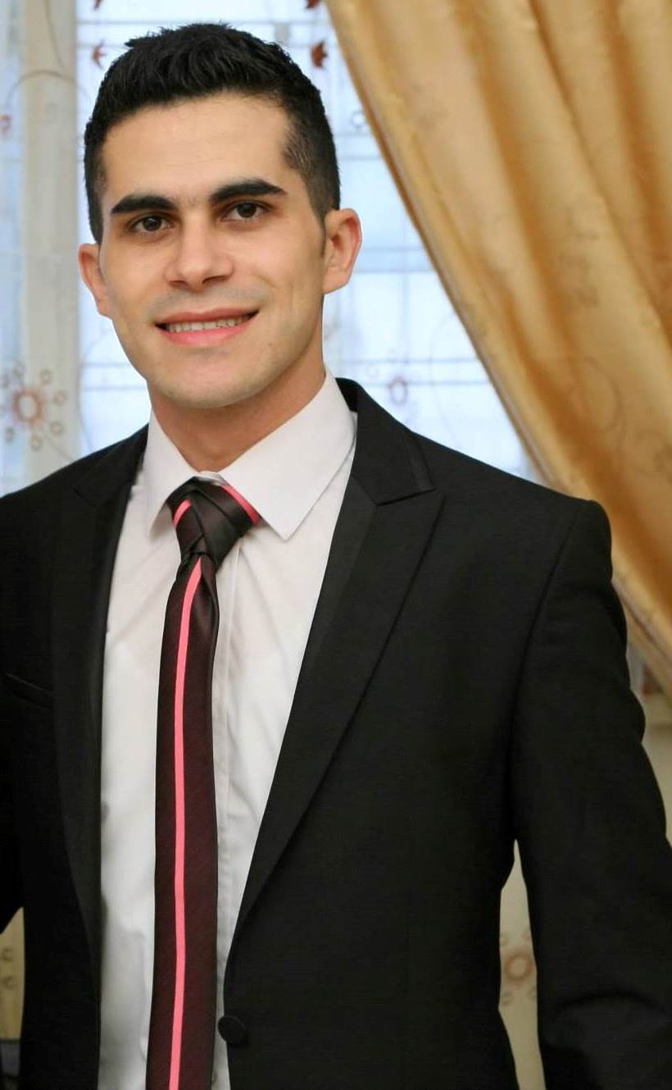
Personal information
 | Tawk, Elie
 | Bakhos Bldg, Saint Josephe’ St., Dora, Lebanon.
 | Mobile: 961- 3- 581 128
 | Elie.tawk1@gmail.com
 | September 19th, 1988.
 | Single
Desired Employment / Objective  Work Experience | To obtain a position whereby demonstrated skills, acquired knowledge and experience may be utilized for advancement, challenge and growth.  Staybridge Suites Beirut  November 2014 – Present Date  Front Office Supervisor:  - Provide outstanding services and ensure guests satisfaction.  - Address customer concerns and complaints promptly and professionally.  - Respond to customer needs and requests in a timely manner  - Plan and assign workloads for front office associates.  - Supervise associates in their assigned job duties.  - Prepare operational and financial records for Manager to review.  - Identify resource requirements and manage resource allocations to ensure complete coverage and continuous availability.  - Assist in hiring and training associates in front office duties.  - Evaluate the performance of associates and provide appropriate feedback.  - Ensure associates follow company policies and operational procedures.  - Schedule regular meetings to discuss about issues and updates.  - Educate associates on safety, emergency and security procedures.  October 2013 – October 2014  Front Office Agent  - Register guests and assigns rooms. Accommodates special requests whenever possible.  - Assists in preregistration and blocking of rooms for reservations.  - Thoroughly understand and adheres to proper credit, check- cashing, and cash handling policies and procedures.  - Understands room status and room status tracking.  - Uses suggestive selling techniques to sell rooms and to promote other services of the hotel.  - Coordinates room status updates with the housekeeping department by notification housekeeping of all check outs, late checkouts, early chek-ins, special requests, and day use rooms.  - Performing cashier related functions like posting charges to guest accounts, raising paid out's, currency exchange,  - Attends department meetings.  - Understand that business demands sometimes make it necessary to move employees from their accustomed shift to other shifts.  Mr. Mohamad AL Ghali – 03/025772
Work Experience  Trainings: | Phoenicia Intercontinental  Guest Services Supervisor : (July 2010 – September 2013)  - Handle the Coverage stay of guests through Travel Agencies.  - Responsible for the speedy and courteous answering of incoming telephone calls, providing all necessary information to callers, and transferring all calls to the related departments.  - Handle guest’s needs or requests and reports complaints to the Duty Manager.  - Responsible for the rendering secretarial, clerical and related assignments to the hotel guests.  - Maintain perfect relationships with all guests to guarantee perfect customer service.  - Monitors automated systems including fire alarms and telephone equipment when engineering and maintenance department is closed.  - Assist in reporting telephone equipment or service complaints and problems.  - Train or assist in training new telephone operators in performance of job duties.  - To be fully aware of and adhere of health and safety, fire and bomb threat procedures.  - Update directory information on the front office software.  - Dispatch international courier with DHL or Aramex.  Section’s Training Ambassador:  - Responsible to plan, implement, and review Section Training to ensure it meets the needs of the Business.  - Ensure all Tasks breakdown is up to standards and complete.  - Plan a 6 months training plan and cascade the learning objective relative to each month and monitor training.  - Responsible for newcomers and trainees’ trainings.  - Monitor grooming standards and product knowledge  Mrs. Rima Korban Abu Samra – 03/408334  Front Office: Support and concierge assistance (February 2009 – July 2010)  - Handle the Coverage stay of guests through Travel Agencies.  - Handle General Security Data.  - Update Guest Profile and history.  - Handle incoming and outgoing parcels.  - Restaurant reservation.  - Ticket Confirmation.  Mrs. Rima Korban Abu Samra – 03/408334  Commis Chef (June. 2007 – Jan. 2008)  - Oriental and butchery kitchen department  - 1 month Cross Exposure at Sales and Marketing Department at Phoenicia Beirut Hotel - September 2012 - October 2012:  - - Reservation department, Field and Sales, Banquets Sales .  - First Aid training Certificate
Education  Personal Skills & Competences  Computer skills  Mother tongue(s)  Other language(s) | - BA Hospitality Management - Al Kafaat University - 2013  - Graduated BT3 rank first at Kafaât Catering School, signed by the Chef Ramzi Chouwayri Director of the Al-Kafaât Catering school - 2007  - Japanese Certificate from the H.E. the Ambassador of Japan in Lebanon Mr. Yoshihisa Kuroda “Project for far-east culinary” - 2007  - Brevet Certificate - St Therese school Lebanon - 2004  - Ability to work in fast paced environment as a team player or independently.  - Communicate effectively in person and via telephone.  - Handle all matters with ultimate diplomacy and confidentiality.  - Opera System for Hotels.  - Micors, FBM.  - QEMS: Quality and Engineering Management System.  - Microsoft Word  - Internet  Arabic.  English: Reading, Writing, Speaking: Excellent  French: Reading, Writing, Speaking: Basic User.
Centers of Interests: | Scout, swimming, walking and skiing.

