Curriculum Vitae 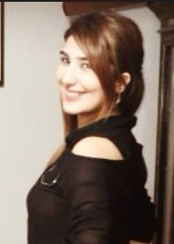

Personal Information:
Name : Nourhan Dokor
Place and Date of Birth : Beirut / July28 /1995
Gender : Female
Marital Status : Single
Nationality : Lebanese

Address : Aramoun – Sheba’a Street – Riyad Shehab Bldg
Tel : 00961 76 734 344 (mobile)

E-mail : Nourhan_nour@live.com

Experience:
- April 2014 – Sales Consultant + Cashier – La Senza

Education:
- Business English – American Language Center Hamra
- Ticketing At Mira Center hamra
( 2 Certificate From : Ministry Of Education & Higher Education + British Certificate )
- Grade 10

Training:
- June 2014 – Present ( Atto Agency Travel Hamra )

Language:
Oral and written Arabic (Excellent)
Oral and written English (Excellent)
Oral and written French (Slight)

Computer Skills:
Use of Galileo System, Outlook, Retail Total Solution, Microsoft Office, Internet

Hobbies:
Music, Swimming

Other information is available upon request.

